Getting started with your systematic review

Introduction
Systematic reviews are primarily evidence-based pieces of research that methodically compare research in an unbiased manner so that the ultimate conclusions stand up in accordance to the evidence presented.
Systematic reviews are measured against a set of specific criteria outlined at the start to help you achieve this.
It is important for research to be undertaken using a structured and controlled approach. You must be clear of your aims and objectives when embarking on a new study or a review of earlier thinking.
Tip: Systematic reviews are measured against a set of specific criteria outlined at the start to help you achieve this.

What is a systematic review?
A systematic review is a tightly structured literature review that focuses on a topic with strict research parameters. The methodology used to collect research has to be consistent in order to reduce misinterpretation and misrepresentation of the data.
The aim of a systematic review is to identify, analyse, appraise and arrive at a considered judgement or set of conclusions based on all the available information and data that adheres to the review’s predetermined set of conformities. Each piece of research material is examined and compared to other similar studies, resources and summarised accordingly. Some people keep records in a form or table summarising each reviewed article which they refer to when collating the evidence.

Why do we conduct systematic reviews?
The purpose of following this very strict protocol is to gather evidence-based research that supports a balanced and unbiased conclusion. Statistical information can be extracted and analysed using a process known as meta-analysis.

What is a systematic literature search?
A systematic literature search is a literature review on a database (such as Medline) which demonstrates that you have compiled a list of appropriate search terms and included the structure of your search history. This provides the evidence on which your assignment is based.
This is a less rigorous process than a systematic review. A systematic review usually covers a wider scope; you would be expected to look at all the available research in the area in question. For example, you would be expected to visit the Library if articles were only held in hard copy format, and where necessary obtain articles not held by the Library via our Inter Library Loans Service.
You may be told that you need to conduct a systematic review when in fact you just need to perform a literature search in a systematic manner.
Tip: Usually at undergraduate level you would not be expected to exhaust every avenue of information and find every article in your research area.

Systematic review vs systematic literature searches
It is important that you understand the difference between the two because the parameters of “searching systematically” are far more flexible than those for a systematic review.
Your tutors will often expect you to perform a systematic search on a database to encourage best academic practice. This also reduces reliance on Google and Google Scholar which, though valid, does not show how you arrived at the set of references detailed in your bibliography. Your reference lists are supposed to reflect the arguments presented in your assignments; the reference lists provide the evidence.
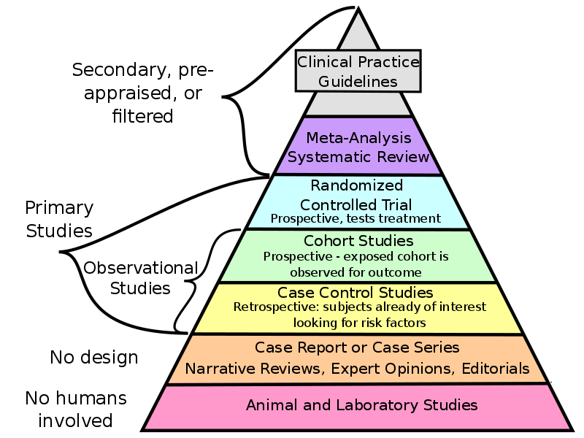
Examples of types of evidence — Creative Commons Attribution-Share Alike 4.0 International
Evidence-based assignments do not always have to be systematic reviews, and most undergraduate assignments are not systematic reviews. There are lots of different types of reviews which vary slightly in methodology.
One of the characteristics they share is that all of them have a basic structure that has been given some thought by the person writing the report. Thus, when marking your work your tutors are looking at the strengths, weaknesses and depth of your arguments and assessing the evidence you have used to back your arguments up.
Depending on the level you are working at, some systematic reviews may take several months, even years to complete, especially if you are conducting research as part of a PhD. Some involve a collaboration of people whilst others could be undertaken over a matter of months. This is usually the case for people embarking on special dissertation projects at undergraduate or taught master’s level.

Summary
Systematic reviews have defined parameters, such as clear inclusion and exclusion criteria. Search terms should be consistently applied across the resources searched. The methodology should be clear to the reader. The results should be explained concisely in a paragraph and/or in the appendices.

