

**Sharing outputs throughout the research lifecycle**



This guide has been developed to inform and support researchers on how to share various research outputs throughout the research lifecycle, including guidance on using relevant tools and systems to do so, and the benefits of this. It is not a comprehensive guide to University research systems, or a guide to all systems that can support you throughout the research lifecycle.

Researchers will need to interact with many other tools and systems to undertake different aspects of the research process – this guide focuses on tools to facilitate sharing of outputs.

There are **two ways** to use this guide either by **working through every section in order**

or by using the **course menu** to navigate to the sections you want.

Not all research activities or outputs will be applicable to all research disciplines, but we hope this guide will encourage you to consider a broader range of things that you produce during your research as outputs worthy of sharing, if it’s appropriate to do so.

**SECTION ONE: RESEARCH LIFECYCLE**

**Introduction to research publishing**

**Research lifecycle**

**SECTION TWO: PLAN AND DESIGN**

**Protocols, Methodologies and Data Management Planning**

**Sharing your early research outputs**

**Developing a publication strategy**

**SECTION THREE: CONDUCTING RESEARCH**

**Conducting research and sharing research data**

**Platforms for sharing research data**

**SECTION FOUR: DISSEMINATE**

**Sharing your research outputs**

**Licencing and amplifying research**

**Monitoring reach and indications of impact**

**SECTION FIVE: PRESERVE AND REUSE**

**Preserve and reuse**

**Further support**

**SECTION SIX: WANT TO KNOW MORE?**

**More information on sharing research, including benefits.**

**To share or not to share?**

**Open Research Tracker**

**In a hurry?**

**Feedback survey**

*1 of 17*

# Introduction to research publishing



In today's ever-evolving research landscape, sharing research as openly as possible is key to driving innovation and maximising its potential societal impact. The University of Manchester is committed to cultivating an open and responsible research environment, as [affirmed in the University ’s Our Future strategy, and our Position Statement on Open Research centres principles of transparency, collaboration, and the public availabilit](https://documents.manchester.ac.uk/DocuInfo.aspx?DocID=55136)y of research data and outputs. This translates into two key expectations of research staff and students:



Credit: Royalty Free - Articulate Content Library 360

That researchers, in discussion with collaborative partners, build Open Research practices into their research workflows wherever practical.

That research outputs will be as open as early as possible.

### Open Access publishing

Many researchers will be familiar with Open Access publishing, and how to arrange this for journal articles, book chapters or monographs generated at the end of the research process.

However, there are many opportunities to share throughout the entire journey of your research project and not just a final paper at the end. Sharing more research outputs, earlier in the process, offers many potential benefits. Doing so can enhance the quality and reach of your work. By opening up your methodologies, datasets, and preliminary findings, you're not just inviting feedback, you're inviting collaboration. Open sharing throughout the process is a means of refining your work and broadening your perspective.

Credit: Royalty Free - Articulate Content Library 360

#### Open Access publishing Library support

Click here if you’d like to learn more about how the Library can support you with Open Access publishing

[**LIBRARY SUPPORT**](https://www.openresearch.manchester.ac.uk/research-services/open-access/)

Open sharing of research is not just about publishing traditional publications Open Access. There are many opportunities to share throughout the entire journey of your research project, not just a final paper at the end, and sharing more research outputs earlier in the process offers many potential benefits**.** Visit section six 'Why share your research openly?' for more information.

**Section six: Why share your research openly?**

Click on the button on the right to jump to section six 'Why share your research openly?' for more information.

**WHY SHARE?**

Every form of output from your research journey holds value, whether it's a dataset, a protocol or a conference presentation. By sharing these outputs, you're contributing to a more inclusive and transparent research community, where knowledge is freely exchanged and built upon. This lays the groundwork to accelerate the development of knowledge and understanding, both within academic disciplines and beyond, to real- world applications in many aspects of life.

**NEXT**

*2 of 17*

# Research lifecycle

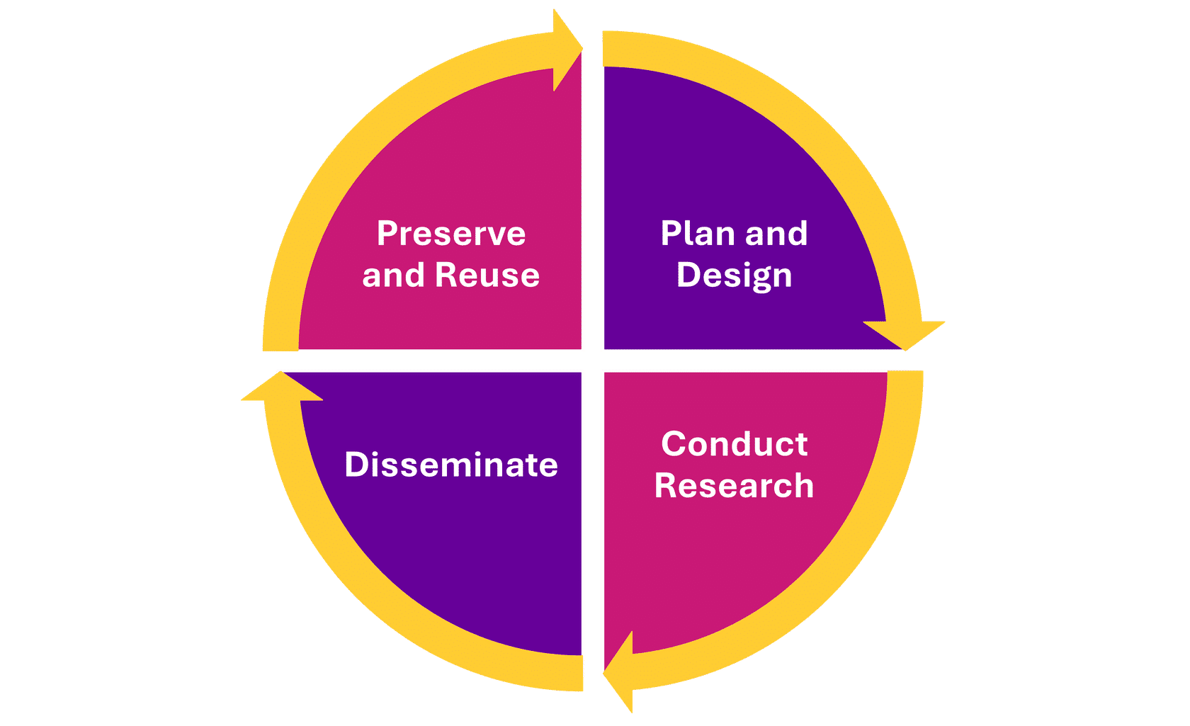

**Research Lifecycle Model** Credit: University of Manchester)

The research lifecycle is the process that you move through when producing your research. There are four phases that you will move through. These are,

 Planning and Design

 Conduct Research

 Disseminate

 Preserve and Reuse

**NEXT**

The next sections will take you through each phase of the research lifecycle and will

demonstrate how you can share your research outputs at each phase.

Research outputs can be shared throughout all stages and the cycle is continuous.

*3 of 17*

# Protocols, Methodologies and Data Management Planning

**Phase 1 Plan and Design**

At the start of the research process, you, the researcher will design your study and approach, and plan out how you’ll conduct the research.

This typically includes,

defining research questions, developing hypotheses, designing methodologies,

outlining how data will be collected and analysed.

You may also consider or finalise details of funding and associated requirements at this point.

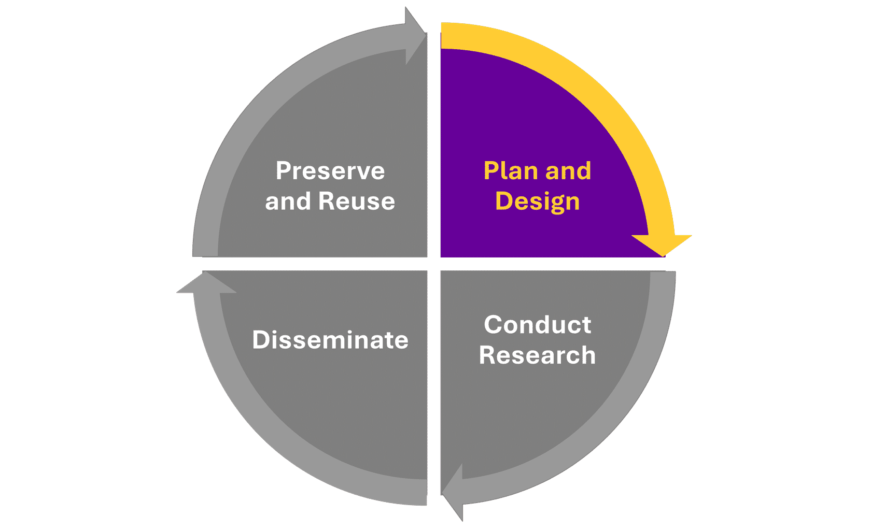

**Research Lifecycle** Credit: University of Manchester)

When developing your research strategy, you should consider the audiences you are intending to reach with your research. Depending on the nature of your work, this may include audiences beyond academia, such as policy makers, industry, patients, or the general public. The wider the potential use and benefit of your research, the more openly you should aim to share your outputs, if it’s appropriate to do so.



|  |  |  |
| --- | --- | --- |
| Credit: Royalty Free - Articulate Content Library 360  The University provides expert guidance and support to help you in this decision-making, and ensure you factor in all important considerations. This includes:  [Research Governance, Ethics and Integrity](https://www.staffnet.manchester.ac.uk/rbe/ethics-integrity/), including an [interactive decision tool.](https://www.training.itservices.manchester.ac.uk/uom/ERM/ethics_decision_tool/story_html5.html) Trusted Research guidance, provided by [Research and Business Engagement](https://www.staffnet.manchester.ac.uk/rbe/rs/preparing/) [Research Risk Profiler tool](https://www.rlp.manchester.ac.uk/2024/01/17/rrp/)  [Information Governance Office](https://www.staffnet.manchester.ac.uk/igo/information-governance-office/)  [The Library 's Research Data Management service](https://www.openresearch.manchester.ac.uk/research-services/research-data-management/)  Even at this early stage, there may be research outputs created which would be beneficial to share as openly as possible. These include, Protocols, Methodologies and Data Management.  **Click on the tabs below to find out more.** | | |
| **PROTOCOLS** | **METHODOLOGIES** | **DATA MANAGEMENT PL AN** |
| A research protocol is a detailed plan that outlines the objectives, methodology, procedures, and logistics of a research study. It serves as a blueprint for conducting the research, ensuring that the study is conducted systematically and ethically. A protocol typically includes the research question or hypothesis; study design; participant selection criteria; data collection methods; data analysis plan; ethical | | |

|  |  |  |
| --- | --- | --- |
| considerations; and potential risks and benefits associated with the study. | | |
|  | | |
| **PROTOCOLS** | **METHODOLOGIES** | **DATA MANAGEMENT PL AN** |
| A methodology refers to the systematic approach or framework used by researchers to conduct a study and to answer specific research questions or test hypotheses. It encompasses the theoretical principles, concepts, techniques, and procedures employed in gathering, analysing, and interpreting data. Research methodology can vary depending on the discipline, research objectives, and the nature of the study, and may include qualitative, quantitative, or mixed methods approaches. | | |
|  | | |
| **PROTOCOLS** | **METHODOLOGIES** | **DATA MANAGEMENT PL AN** |
| A Data Management Plan (DMP is a formal document outlining how a research project will manage data both during and after the research project. University of Manchester researchers are required to produce a [DMP for every research study (see UoM Research Data Management policy), and it is a requirement of many funders as part of grant](https://documents.manchester.ac.uk/DocuInfo.aspx?DocID=33802%20) applications. A completed DMP should be accessible to all those working on a given research project, and you may wish to share your DMP beyond the research team as well. | | |
|  | | |
|  | | |

**NEXT**

*4 of 17*

# Sharing your early research outputs

**Protocol or methodology**

Sharing your research protocol and or methodology contributes to the reproducibility of your research. By documenting your planned approach and intentions, you’re facilitating the replication of the research process, supporting the reliability and credibility of research findings, and building trust in the research community. When research results can be reproduced by independent parties, it increases confidence in the validity of those findings, and allows for building upon existing knowledge with greater certainty. Through creating and sharing protocols and methodologies, you’re also supporting future investigation and analysis by other researchers working on similar or connected topics, potentially making the research process more efficient.

**Preregistration**

One way of sharing protocols or methodologies is through preregistration. Preregistration is the practice of registering a research study's hypothesis, methodology, and analysis plan before conducting the study or analysing the data. This helps to enhance the transparency, credibility, and reproducibility of research by reducing bias and preventing researchers from modifying their methods or hypotheses after data collection based on the results obtained. Preregistration can involve registering the study with a publicly accessible registry or repository, providing detailed information about the study design, [variables, and analysis plan. Check out this primer on preregistrations and registered reports from UKRN for more details.](https://www.youtube.com/watch?v=q4yf7Pt4q5c)

|  |  |
| --- | --- |
| The [Office for Open Researc](https://www.openresearch.manchester.ac.uk/)[h](https://manchester-uk.libanswers.com/OOR/faq/278810) has established institutional access to the following platforms which support the open sharing of protocols, methodologies and preregistrations: | |
| **OPEN SCIENCE FRAMEWORK ( OSF)** | **PROTOCOLS. IO** |
| Open Science Framework (OSF is an open research management tool designed to improve research collaboration by enabling effective sharing of the research process. It facilitates open, reproducible research pipelines from preregistration through to data collection and analysis. OSF serves as a centralised project platform seamlessly integrating with existing workflows and external storage systems.  You can access support and more information on how to sign up to  OSF via our dedicated [Office for Open Research for OSF](https://manchester-uk.libanswers.com/OOR/faq/278810) knowledge base article | |
|  | |
| **OPEN SCIENCE FRAMEWORK ( OSF)** | **PROTOCOLS. IO** |
| Research papers and protocol organisation often lack detailed instructions for repeating experiments. Protocols.io is a secure open access platform for developing and sharing reproducible methods.  Users can create, publish, and read public protocols.  University of Manchester staff and students can also create private areas for method development, collaboration, and tracking protocol | |

|  |
| --- |
| execution records. The platform helps authors bring structure to their research, whilst effectively building on the practices and methods of others.  [Here you will find details of how to sign up to the Office for Open Research](https://manchester-uk.libanswers.com/OOR/faq/278811) [Protocols.io](https://manchester-uk.libanswers.com/OOR/faq/278811) [knowledge base article.](https://manchester-uk.libanswers.com/OOR/faq/278811) |
| **Share your Data Management Plan (DMP**  Depending on the nature of your research, you may also wish to consider sharing your Data Management Plan (DMP beyond the research team with whom you’re collaborating. As a DMP is a living document, and should be updated as the project progresses, it’s important to consider when, as well as how, a DMP is shared, if appropriate. Here are three ways to share your DMP more widely, if this is appropriate and of interest:  [RIO journal](https://riojournal.com/about)  [Digital Curation Centre](https://www.dcc.ac.uk/resources/data-management-plans/guidance-examples) [Figshare](https://figshare.manchester.ac.uk/) |



Credit: University of Manchester

Remember to consider the appropriateness of sharing your DMP beyond the research team. Form more information and support click on the buttons below.

**To share or not to share?**

|  |
| --- |
| For more information on the appropriateness of sharing click on the button and read the section on "To share or not to share?"  **SHARE?**  **Need help with creating a Research Data Management Plan?**  Contact the Library’s Research Data Management team for expert support and guidance  [**SUPPORT**](https://www.openresearch.manchester.ac.uk/research-services/research-data-management/) |
| **NEXT** |

*5 of 17*

# Developing a publication strategy

**Develop a publication strategy, planning ahead to share your findings**

Even if you haven’t yet begun your research or analysis, it’s worth taking some time to consider how you’ll ensure that your eventual outcomes and findings can be discovered, accessed and used by as many interested people as possible – both within and beyond academia. A smart way to do this is through creating a publication strategy. This can include considering how you’ll present and share your findings, including the formats, platforms and journals you’d like to target.

Publishing your findings in a peer reviewed academic journal is a well-established and significant means of sharing your research. Each discipline has journals that are considered highly reputable and whose readership includes peers and influential colleagues, and there are many considerations for researchers choosing a journal, including Open Access publishing options. The Office for Open Research can support you. Here are some useful links:

[**Getting** **publishing in academic journals**](https://www.education.library.manchester.ac.uk/mre/getting-published/)[**Open Access**](https://www.openresearch.manchester.ac.uk/research-services/open-access/)

[**Predatory** **publishing guidance workshop**](https://www.library.manchester.ac.uk/training/my-research-essentials/workshops/details/?event=6jvebWXe)

Formal publication of your research findings is only one way to enable awareness, use and recognition of your work. When developing a publication strategy, you can consider opportunities to amplify and target your research outputs to maximise their potential reach, benefits and impact.



Credit: University of Manchester

## Claim an ORCID

You’ll be keen to ensure that all outputs that you publish are correctly attributed and linked to you throughout your career, even if you move institutions or change your name.

|  |
| --- |
| An ORCID Open Researcher and Contributor ID is a unique identifier that allows you to distinguish yourself from other researchers, even if you share your name and research discipline!  Your ORCID provides a definitive record of your research activities and a personal profile page, both accessible via the open ORCID registry. It’s a useful identifier for linking you authoritatively to your research outputs, funding data, and employment history.  This process is free and enables you to manage your record of activities and search for others in the registry. Once you have an ORCID, you can link it to other accounts such as Pure, which can then automatically update your ORCID with new research outputs and employment details, saving you time and ensuring an up-to-date record of your research activity.  University of Manchester Postgraduate researchers are required to claim an ORCID and record this in Pure by the point of their Year 1 review. |
| **Register for ORCID**  To obtain an ORCID, you need to create an account via the ORCID registry website .  [**ORCID REGISTRY**](https://orcid.org/)  **Managing your ORCID in Pure**  For more information on managing your ORCID in Pure, you can refer to this guide: Managing your ORCID in Pure.  [**ORCID IN PURE**](https://medium.com/%40manlibresearch/managing-your-orcid-84ab069a4b5d) |

**NEXT**

*6 of 17*

# Conducting research and sharing research data

**Phase 2 Conduct Research**

The next step is to undertake your research. This will look very different to each researcher depending on your discipline and focus, but will always involve gathering and then analysing some form of data according to your research plan, whether through experiments, surveys, observations, or other methods. Researchers should follow protocols, record data, and ensure that ethical considerations are met.

You may generate research outputs even as you are actively undertaking your research, and it’s worth considering sharing these to support and enhance collaboration and reproducibility.

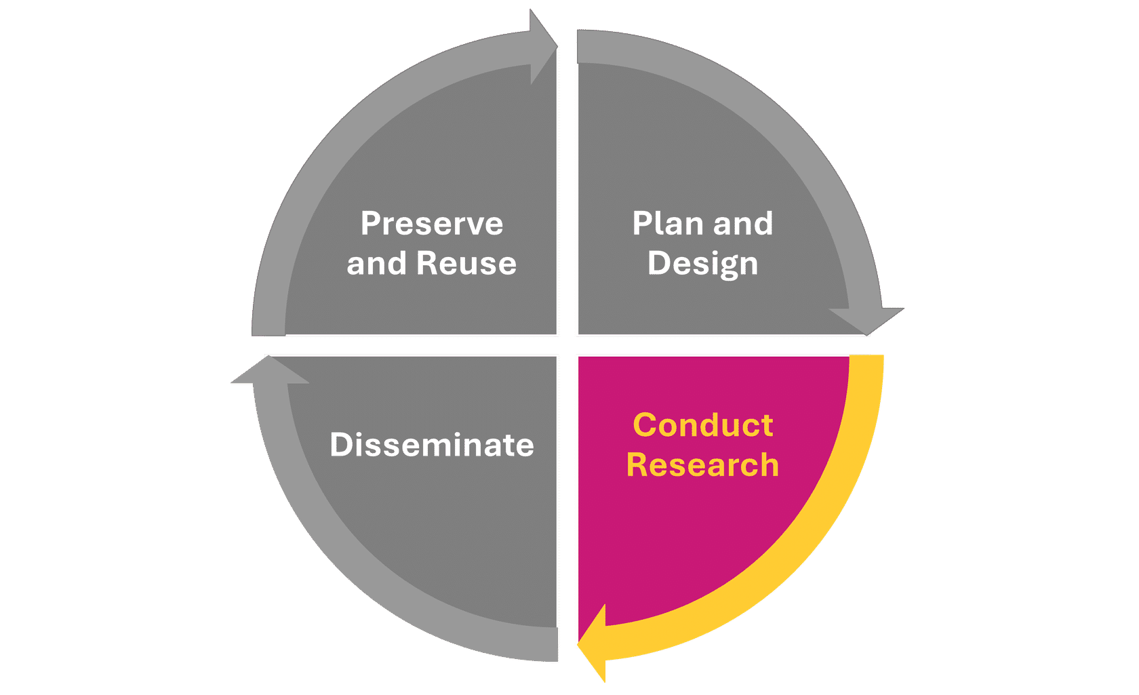

**Research Lifecycle** Credit: University of Manchester)

## Research data

Research data encompasses the raw, processed, or analysed information collected or generated during the course of a research project. Data can take various forms depending on the discipline and the nature of the research, it can be quantitative, qualitive using different types of media and data. Click on the flip cards below for examples and more information.

Quantitative

For example, measurements, sensor readings, clinical trial data, genomic sequences, spectroscopic data, census data, or historical datasets.

Qualitative

For example, experimental observations, survey responses, interview transcripts, archival documents, or ethnographic field notes.

|  |  |  |  |  |
| --- | --- | --- | --- | --- |
|  | Other material types |  | This may include audio, visual, or other non-textual or numerical data – or elements of all these things! This could include patient records, medical imaging files, text corpora, audio visual recordings, or simulation outputs. |  |
|  | | | | |

**Sharing restricted data**



Credit: Royalty Free - Articulate Content Library 360

|  |
| --- |
| It may not be appropriate to share your research data openly (see below "To share or not to share?"). However, it may still be possible to enhance the discoverability and transparency of your research by carefully sharing restricted data. Most research data can be shared using a combination of informed consent, anonymisation and controlling access to data. If you need to control who will access your research data, rather than making it openly available, then you can share your data in repositories offering restricted access such as the [UK Data Service](https://ukdataservice.ac.uk/deposit-data/). You can make the metadata record open, which will ensure that your research is more findable and transparent than if there were no record available. |
| **To share or not to share?**  For more information on the appropriateness of sharing click on the button and read the section on "To share or not to share?"  **SHARE?** |
| **NEXT** |

*7 of 17*

# Platforms for sharing research data

Regardless of discipline, research data should be appropriately documented, organised, and stored to ensure its integrity, accessibility, and reuse. This often involves adherence to disciplinary standards, data management best practices, and legal and ethical considerations related to data sharing and privacy. Open sharing of data, where appropriate, supports transparency and reproducibility of research by allowing others to verify findings and methods, and accelerate scholarly progress by allowing researchers to build upon existing findings more efficiently. Many funders also have data sharing policies which mandate that data from the projects they fund must be made as Findable, Accessible, Interoperable and Reusable ([FAIR](https://www.go-fair.org/fair-principles/)) as possible.

There are many platforms available to share research data:

|  |  |  |
| --- | --- | --- |
| Credit: Royalty Free - Articulate Content Library 360 | | |
|  | | |
| **FIGSHARE** | **REPOSITORIES** | **ELECTRONIC RESEARCH NOTEBOOK** |
| [Figshare](https://figshare.manchester.ac.uk/) is the University’s supported institutional research data repository. It can be used to deposit and publish data which is suitable for sharing openly, in any file format. Publishing data via Figshare helps to make your data outputs Findable, Accessible, Interoperable and Reusable ([FAIR](https://www.go-fair.org/fair-principles/)).  Published outputs in Figshare:  are provided with a Digital Object Identifier (DOI which can be cited within other research publications, included on websites, shared via social media or in presentations; | | |

|  |  |  |
| --- | --- | --- |
| are discoverable via search engines, expanding the reach of your research;  benefit from usage metrics to show views, downloads, citations and Altmetrics;  will be preserved long-term.  Using Figshare to publish data openly can also fulfil funder requirements for data sharing  Guides and FAQs are available from [Figshare’s support portal,](https://help.figshare.com/section/user-guides) or please contact the Library RDM team for help with using Figshare.  To access Figshare Log In using your university credentials go to; [figshare.manchester.ac.uk](http://figshare.manchester.ac.uk/) | | |
|  | | |
| **FIGSHARE** | **REPOSITORIES** | **ELECTRONIC RESEARCH NOTEBOOK** |
| **For subjects:** If you would prefer a discipline-specific data repository, you can find one for your subject via the link below.  **RE3DATA** - <https://www.re3data.org/>  **Funders:** Some funders expect data to be deposited in specific repositories, for example ones that support dedicated data centres and EU or Horizon 2020-funded researchers. Find out more on the links below.  **ESRC** - <https://www.ukri.org/councils/esrc/> | | |

|  |  |  |
| --- | --- | --- |
| **NERC** -<https://www.ukri.org/councils/nerc/facilities-and-resources/>  **ZENODO** - <https://zenodo.org/>  **OSF ** [University of Manchester's Open Science Framework](https://www.openresearch.manchester.ac.uk/resources/tools/osf/) | | |
|  | | |
| **FIGSHARE** | **REPOSITORIES** | **ELECTRONIC RESEARCH NOTEBOOK** |
| An Electronic Research Notebook (ERN is a digital version of the traditional paper lab notebook commonly used by researchers, especially in scientific disciplines, to record experimental procedures, results, observations, and other relevant data. ERNs are sometimes referred to as Electronic Lab Notebooks or ELNs). ERNs offer an efficient and secure way for researchers to document their work, collaborate with colleagues, and maintain a comprehensive record of experiments and findings.  Data can be organised efficiently using customisable templates, folders, and tags, and ERNs often include version control and data encryption to ensure the integrity and security of experimental data. It may also be possible to integrate an ERN with laboratory instruments, data analysis software, and other research tools, which can streamline data collection and analysis workflows. There are dozens of Electronic Research Notebooks available.  The Research Lifecycle Project (RLP is exploring these platforms, and you can use [ELNFinder](https://eln-finder.ulb.tu-darmstadt.de/home) to identify the most suitable one for your needs. You can share elements and outputs of your ERN via [Figshare](https://figshare.manchester.ac.uk/) or [OSF](https://manchester-uk.libanswers.com/OOR/faq/278810) – check out this [case study](https://info.figshare.com/figshare-researcher-spotlight-james-bird-the-university-of-manchester/) for an example. | | |
|  | | |
| **Preprint** | | |

|  |  |  |  |
| --- | --- | --- | --- |
| A preprint is a version of a scholarly or scientific paper created prior to formal peer review and publication in a peer-reviewed journal. It’s an initial draft of a research article that researchers share publicly to gather feedback and disseminate their findings rapidly within the scholarly community. Check out this [preprints primer from UKRN](https://www.youtube.com/watch?v=syef3PPltG0) for more detailed information. Openly sharing a preprint allows you to receive initial feedback from peers quickly, which can help improve the quality of your work before formal publication, as well as supporting collaboration and discussion within your research community.  Posting a preprint also allows you to establish the priority of your work and claim ownership of your insights and discoveries, even before the formal peer-review process is complete. Preprints can be shared in a number of ways: | | | |
|  | | | |
| **PREPRINT SERVERS** | **PURE** | **OVERLEAF** | **OCTOPUS** |
| There are a number of preprint servers available which are often discipline- specific including via preprint servers which are often discipline-specific ([**arXiv**](https://arxiv.org/)for physics, mathematics, computer science, and related fields, [**bioRxiv**](https://www.biorxiv.org/)for biology, and [**medRxiv**](https://www.medrxiv.org/)for health sciences). The Office for Open Research runs [**CrimRxiv**](https://www.crimrxiv.com/), an archive for criminology research, and contributes financially to support the running of [**arXiv**](https://arxiv.org/)and [**PsyArXiv**](https://osf.io/preprints/psyarxiv).  Here is a list of the URLs for the links above.  **arXiv** <https://arxiv.org/>  **bioRxiv** <https://www.biorxiv.org/> **medRxiv** <https://www.medrxiv.org/> **CrimRxiv** <https://www.crimrxiv.com/> **PsyArXiv** <https://osf.io/preprints/psyarxiv> | | | |
|  | | | |

|  |  |  |  |
| --- | --- | --- | --- |
|  | | | |
| **PREPRINT SERVERS** | **PURE** | **OVERLEAF** | **OCTOPUS** |
| You can also upload preprints to Pure, the University’s Current Research Information System, where they will appear on your research profile on Research Explorer; you can connect a preprint to other research outputs like the version of record. The version of record is the final, definitive version of a research output which has undergone peer review, copyediting, formatting, and final approval by the publisher. It is the authoritative version that is usually cited and referenced in scholarly work.  [https://pure.manchester.ac.uk](https://pure.manchester.ac.uk/) | | | |
|  | | | |
| **PREPRINT SERVERS** | **PURE** | **OVERLEAF** | **OCTOPUS** |
| Overleaf is an online collaborative writing and publishing tool that enables authors to create professional-looking documents using [LaTeX](https://www.latex-project.org/). It’s designed to simplify the process of writing, editing, and producing academic papers and documents by managing the formatting through predefined templates. You can use Overleaf to collaboratively write your journal article with your co- authors, ahead of sharing it as a preprint or later version. Overleaf Professional accounts are freely available to all current University of Manchester staff, postgraduate researchers, and active members of the research community.  [To sign up, use your University of Manchester email address at the University of Manchester resource portal.](https://www.overleaf.com/edu/theuniversityofmanchester) | | | |
|  | | | |

|  |  |  |  |
| --- | --- | --- | --- |
| **PREPRINT SERVERS** | **PURE** | **OVERLEAF** | **OCTOPUS** |
| Octopus is a software platform designed to improve the efficiency, transparency, and reproducibility of the academic publishing process by implementing open-source principles and standards. It offers features to effectively manage the workflows of publication, such as manuscript tracking, peer review management, version control, and integration with repositories for data and code.  Additionally, Octopus supports open access publishing models, enabling researchers to freely access and disseminate their work. Unlike the traditional publishing medium of a journal, Octopus divides publications into smaller, linked units where you can describe each stage of the research process – for example, hypothesis, method, results, analysis – in full detail. You don't need to publish every stage, but can choose which stage/s you’d [like to document and publish. You can find more information via Octopus’ FAQs.](https://www.octopus.ac/faq) | | | |
|  | | | |

#### Blogs and webpages

Information on blogs or webpages is mention on the

**Licence and amplify your research** page in section 4.

**SHARE ONLINE**

**NEXT**

*8 of 17*

# Sharing your research outputs

**Phase 3  Disseminate**

Once you’ve completed your research activity and analysed and written up your findings, it’s time to concentrate on disseminating the insights that you have gleaned. Traditionally, this is the point in the research process that most sharing of outputs occurs, so you’re likely to be thinking about sharing familiar, well-established output types, like journal articles, monographs and book chapters, and conference proceedings, though there are other outputs you may wish to share as well.

As outlined in its Position Statement on Open Research, The University of Manchester expects authors to share research outputs openly and as early as possible, adhering to the principle of public accessibility and transparency of research communication. There are specific requirements on sharing journal articles and certain other outputs Open Access which must be fulfilled to ensure compliance with institutional, funder and REF policies, so it’s important to familiarise yourself and act in accordance with these requirements [link to more info]. The Office for Open Research provides guidance and support to help you fulfil [these requirements](https://manchester-uk.libanswers.com/OOR/search/?t=0&adv=1&topics=OA%20policy) and openly share other output types too.

**Research Lifecycle** Credit: University of Manchester)

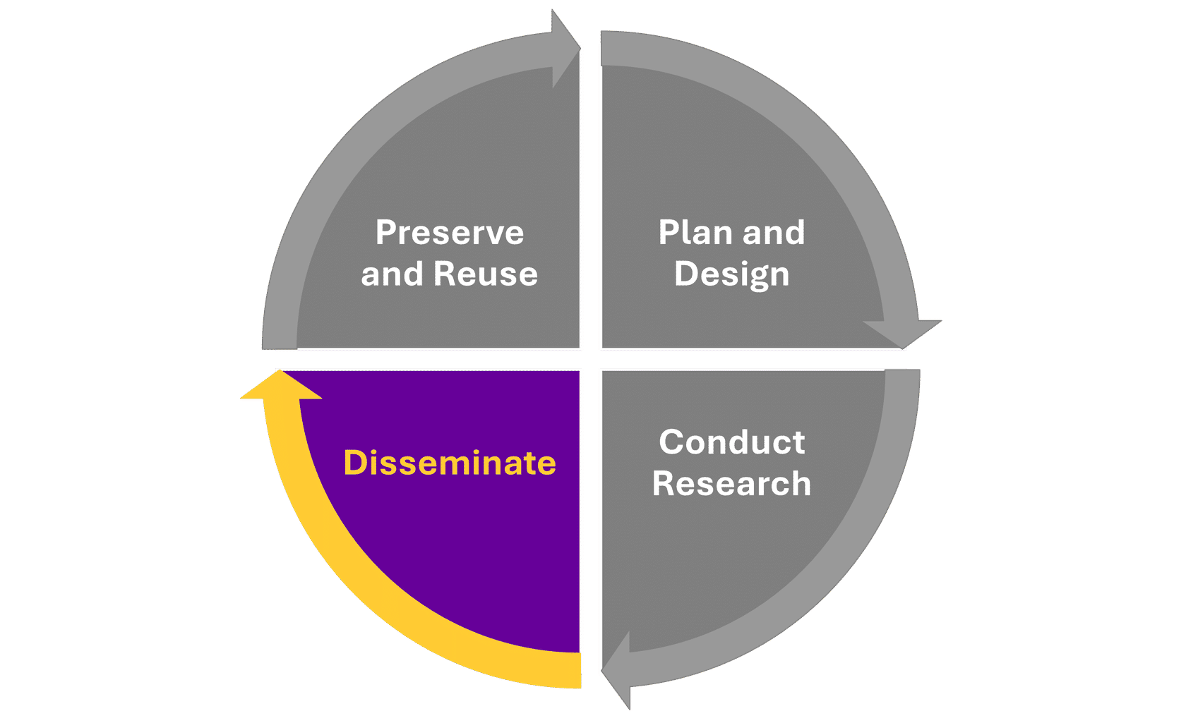

### Code and software

A growing proportion of research relies on software written for that research. Sharing this software (in the form of source code or scripts) allows others to better understand your research and potentially build on the work you have done. If you've created software from scratch and do not plan on commercialising, sharing it publicly could improve the impact of the work you do. If you have built on others’ software, you will need to check the licence the original software was shared under to see if you can release your software.

The licence applied to the original software may only allow you to release your software under certain conditions so it is worth checking carefully. Before sharing any code, it’s important to ensure that you either own the Intellectual Property (IP or have permission from the IP owner.



Credit: Royalty Free - Articulate Content Library 360

You will need to consider when you want to share your software. Some researchers work on their software openly during their project using tools such as GitHub, [GitLab](https://about.gitlab.com/) and [Bitbucket](https://bitbucket.org/), whilst others choose only to release their software publicly on these platforms at the end of the project.

Whenever you share your software, remember to include documentation to allow new users to be able to get set up and running. As with all research outputs, it’s important to apply the correct licence.

If you would like your software to be in a more citable format, consider platforms such as [Figshare](https://help.figshare.com/article/how-to-connect-figshare-with-your-github-account) or Zenodo which have [useful integration with GitHub](https://guides.github.com/activities/citable-code/) and allows you to assign a DOI to a particular version of your software. You may want to include a CITATION.txt file in the base directory of your software repository describing how to reference your source code and how you want your work cited, and a README so people can understand the structure of the software and what files they need to read. Doing so will help to align your code with the [FAIR Principles for Research Software](https://zenodo.org/records/6623556).

As well as sharing the software publicly it is often a good idea to publish a software paper to ensure you get appropriate credit for your software. The Software Sustainability Institute has created a [list of journals that accept software papers](https://www.software.ac.uk/resources/guides/which-journals-should-i-publish-my-software).

|  |
| --- |
| **SHARING RESEARCH DATA**  If you need information on sharing your research data. Click the RESEARCH DATA button on the right.  **RESEARCH DATA** |
| **NEXT** |

*9 of 17*

# Licencing and amplifying research

### Applying the right licence

Licencing is a crucial aspect of sharing research outputs because it defines how others can use, distribute, and build upon the work. The right licence ensures that researchers retain control over their work while maximising its impact and reach. Open licences, such as those provided by Creative Commons, facilitate the dissemination of knowledge by allowing others to freely access, share, and reuse research findings, which can accelerate scholarly progress and innovation. By clearly stating the permissions granted, licences help avoid legal ambiguities and protect both the author's rights and the users' ability to legally engage with the research.

Choosing the appropriate licence depends on your goals for sharing your work. A Creative Commons Attribution (CC BY licence allows others to distribute, remix, adapt, and build upon the work, even commercially, as long as they credit the original creation. This licence is often recommended for maximum dissemination and use. Alternatively, a Creative Commons Attribution-NonCommercial (CC BYNC licence restricts commercial use, allowing others to remix, tweak, and build upon the work non-commercially.

Understanding the different types of licences and their implications is essential to ensure that your work is used in ways that align with your intentions, whilst enabling open scholarship.

You can find more information and support via the following resources:

[Creative Commons License Chooser](https://chooser-beta.creativecommons.org/): helps you select the appropriate Creative Commons license based on how you want your work to be used.

[SPARC Author Addendum](https://sparcopen.org/our-work/author-rights/brochure-html/): helps authors retain key rights to their works when publishing in traditional journals.

[Open Access Scholarly Information Sourcebook (OASIS](http://www.openoasis.org/): provides guidance on open access publishing and licensing options.

<https://choosealicense.com/> : tool to determine the optimum licence for sharing research software, supporting others to use and build upon the software you’ve created.

### Amplifying your research

There’s no guarantee that your research will be discovered. You’ll need to take action to maximise the chance of your work reaching your target audiences, and perhaps also audiences that you haven’t yet identified as able to benefit from and contribute to your work. Sharing your work openly is a good first step, but there’s more you can do to make it as discoverable, accessible and reusable as possible. It’s advisable to consider this at the start of your research project by **developing a publication strategy** which you can implement at this stage to amplify your research.

**Developing a publication strategy**

Click on the quick link button to jump to this section of the guide.

**QUICK LINK**

A range of support is available from the University, either centrally or via your Faculty, to help you promote your research. Here are some useful resources:

University of Manchester's guidance and support: [promoting y our research](https://www.staffnet.manchester.ac.uk/promoting-your-research/)

[Resources and examples of best practice from University of Manchester’s Research Communications Conference](https://www.staffnet.manchester.ac.uk/promoting-your-research/tools-resources/conference-slides-videos/)



Credit: University of Manchester

### Lay summary

A lay summary is a concise and simplified explanation of a research study's objectives, methods, findings, and implications, tailored for a non-specialist audience. These summaries can be incredibly useful as they make research more accessible and understandable to the general public, policymakers, and other stakeholders who may not

have expertise in the field. Lay summaries can enhance transparency and trust in science, contribute to bridging the gap between academia and society, and help facilitate informed decision-making.

There are various ways to create a lay summary. You can write one alongside an academic article – some publishers, like PLoS, require authors to do this – or you can create a distinct document. A blog post can provide a lay summary, or you could explore multimedia formats like videos or infographics. Whatever format you choose, it’s essential to prioritise clarity, avoid jargon, provide context, and accurately represent your key findings and their significance. Ideally, aim to present the information in an engaging and accessible manner. You can add your lay summary to Pure and link it to the full research article or output. The platform [Kudos](https://info.growkudos.com/landing/researchers-2023) can be used to easily generate a lay summary of a paper, with basic functionality available free of charge.

### Blogs, social media and websites

Researchers often use blogs or webpages as dynamic platforms to share their work and research progress with a broader audience. You might wish to create a blog to discuss findings, methodologies, and insights in a more accessible format than traditional academic papers, and at an earlier stage of the research process. A blog or project website will allow you to share preliminary findings, solicit feedback, and engage with fellow scholars and the public in real-time. If you’re interested in setting up a blog or website, it’s important to consider where it will be hosted, and how it will be maintained and, ideally, preserved. We recommend contacting your Faculty’s Communications and Marketing team for more information and guidance:

* [Faculty of Biology , Medicine and Health](https://www.staffnet.manchester.ac.uk/bmh/ps-activities/comms-and-marketing/)
* [Faculty of Humanities](https://www.staffnet.manchester.ac.uk/humanities/support-services/communications-and-marketing/advice-and-guidance/)
* [Faculty of Science and Engineering](https://livemanchesterac.sharepoint.com/sites/UOM-FSE-CM)



Credit: Royalty Free - Articulate Content Library 360

Sharing research findings via blogs and social media can offer numerous benefits. Doing this enhances the visibility and accessibility of your work, reaching broader audiences beyond academia, including policymakers, practitioners, and the general public. This can lead to increased citations and collaborations, which can offer the potential of boosting your career prospects. Sharing work via these platforms also facilitates rapid dissemination of findings, potentially accelerating the impact of research on society.

When engaging in sharing via social media and blogs, it’s important to maintain professionalism, ensuring accuracy and clarity in your communication, respecting copyright and privacy, and engaging ethically with diverse audiences. You should also familiarise yourself and act in accordance with UoM’s policies regarding public engagement – see here for examples of support. It’s also advisable to prioritise platforms that are well-used by your target audience, or identify potential platforms to reach broader audiences.

|  |
| --- |
| You might be interested in publishing with The Conversation, an independent, not-for- profit blog designed for academics to provide informed views on topical issues. It features posts written by academics, which are refined with the help of expert editors to ensure readability and quality. This platform enjoys a significant global readership and allows for the republishing of posts on third-party sites under Creative Commons licenses. Through the University’s membership, authors have access to a team of professional editors who can help craft effective and engaging blog posts. For more details or to pitch a blog post idea, visit The Conversation’s website. |
| **NEXT** |

*10 of 17*

# Monitoring reach and indications of impact

What impact is your research having on your field of study, or the wider world? This question is important to researchers, as well as their institutions and funders, for many different reasons, but is hard to answer. It’s difficult to measure impact, but it is possible to monitor the reach of your work, and consider some indications or evidence of realised or potential impact.

There is no individual measure of reach, or by extension, impact of research, and it would be hugely problematic to reduce the complex, nuanced, scientific or creative process of research to an individual or small set of metrics. The University of Manchester is committed to using research metrics responsibly, as evidenced by its endorsement of the [San Francisco Declaration on Research Assessment (DORA](https://sfdora.org/read/) and the principles outlined in the [2022 Harnessing the Metric Tide review](https://rori.figshare.com/articles/report/Harnessing_the_Metric_Tide/21701624). These principles include robustness, humility, transparency, diversity, and reflexivity, ensuring that metrics support qualitative assessments rather than replace them. This commitment means the University uses metrics to inform, not dictate, publication strategies and research assessments. Metrics are applied with caution, especially at the individual output level, and never at the level of the individual researcher, to avoid biases that may affect underrepresented groups. This approach aligns with the University's broader commitment to fairness and transparency in [research evaluation. For more details, you can access the University 's statement on responsible metrics and if you'd like to learn more about using metrics responsibly p](https://documents.manchester.ac.uk/DocuInfo.aspx?DocID=75142)lease see this guide: [Introduction to responsible research metrics.](https://medium.com/research-metrics-matters/part-1-introduction-to-responsible-research-metrics-part-1-4fbe385dd0c4)

### Social media, blog or news mentions

Altmetric Explorer is a platform to help authors track the discussion and impact of their research across various non-academic platforms. This includes monitoring mentions on social media, news outlets, blogs, and policy documents. The tool provides a comprehensive view of how research is being received and engaged with by broader audiences, which is crucial for understanding the societal impact of academic work.



Credit: Royalty Free - Articulate Content Library 360

As a researcher at the University of Manchester, you can use Altmetric Explorer to gauge the reach and influence of your publications beyond traditional academic metrics like [citations](https://manchester-uk.libanswers.com/OOR/faq/279035). Both UoM’s Research Explorer and our institutional data repository, [Figshare](https://manchester-uk.libanswers.com/OOR/faq/279032), provide the Altmetric ‘score’ for each research output deposited, as a way of identifying the reach of an output beyond academia [so far. To start using Altmetric Explorer, access it here. You can also contact the Office for Open Research for more information, support and guidance.](https://www.openresearch.manchester.ac.uk/contact/)

### Citations

Citations serve several critical purposes: they provide evidence to support claims, help readers trace the development of research ideas, and contribute to academic integrity by

|  |
| --- |
| giving credit to original sources. They’re also instrumental in gauging the academic reach and impact of research. They have traditionally been used to assess the quality and influence of a researcher's output by indicating how often their work has been referenced by other scholars. This is often interpreted as a sign of the work's reliability, relevance, and contribution to the field. Citations have also played a crucial role in academic evaluations, influencing decisions related to funding, promotions, and recognitions. It’s important to note that The University of Manchester is committed to responsible use of research metrics like citations – please see above for more information.  There are various tools available to UoM researchers to monitor and analyse the impact of your work through citations. These include:  [Web of Science](https://manchester-uk.libanswers.com/OOR/faq/279002), [Scopus](https://manchester-uk.libanswers.com/OOR/faq/279001) and [SciVal](https://manchester-uk.libanswers.com/OOR/faq/278977) Comprehensive databases that provide detailed citation analysis and metrics, helping researchers understand the influence of their publications. The Office for Open Research manages our institutional subscriptions [to these tools and can support you to access and use these effectively contact the OOR for more information.](https://www.openresearch.manchester.ac.uk/contact/)  [OpenAlex](https://manchester-uk.libanswers.com/OOR/faq/279003) An open-source platform that provides comprehensive citation data by aggregating content from diverse sources. Its openness ensures transparency and inclusivity in data collection.  [Scite.ai:](https://manchester-uk.libanswers.com/teaching-and-learning/faq/270976) Offers a user-friendly way to track citations to articles, presenting a broad view of academic influence across many disciplines, using AI to classify citations as to whether they mention, support or contrast with each research output. Find out more about [Scite.ai here.](https://manchester-uk.libanswers.com/teaching-and-learning/faq/270976)  [Altmetric Explorer](https://manchester-uk.libanswers.com/OOR/faq/279000) While primarily used for tracking mentions across non-academic platforms, it also provides citation data from [Dimensions.](https://manchester-uk.libanswers.com/OOR/faq/278992) See above for more information on accessing this tool.  For more detailed guidance on using these tools effectively, researchers at the University of Manchester can consult the [Research Indicators team](https://www.openresearch.manchester.ac.uk/research-services/research-intelligence/) within the Office for Open Research. We also provide an openly accessible training guide on citation analysis. Click  the button below to find out more. |
|  |

|  |
| --- |
| **Using citation analysis to measure research impact**  This guide explores what citation analysis is, demonstrates how it is used to measure impact, and how you can conduct a basic analysis. It also highlight how citation analysis differs depending on the field of academic study.  [**GUIDE**](https://www.education.library.manchester.ac.uk/mre/citation-analysis/) |
| **NEXT** |

*11 of 17*

# Preserve and reuse

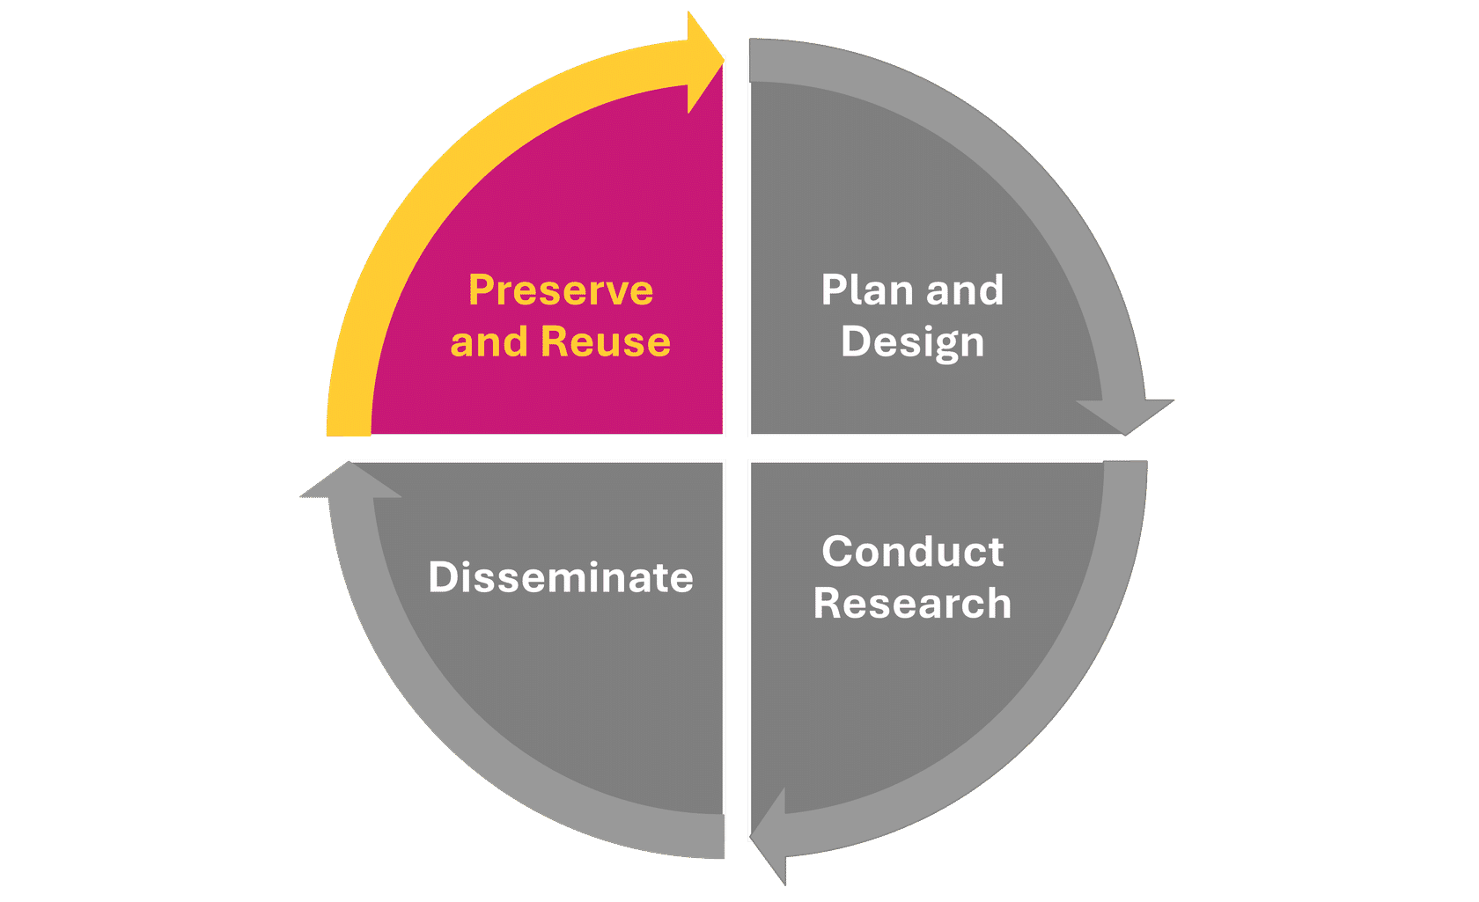

**Phase 4 Preserve and reuse**

You’ve completed your research project and shared your findings with fellow scholars. Hopefully you’ve also shared a range of research outputs created throughout the research process along the way, and made access possible for other interested people outside academia who could benefit from the knowledge that you’ve helped to advance. It’s the end of your specific research project, but the research process is cyclical and continuous. Academic research represents a culmination of diligent efforts, resources, and intellectual contributions, making its preservation essential to prevent loss over time. At this stage, it’s important to ensure that as many aspects of your work as possible are preserved to enable reuse.



**Research Lifecycle** Credit: University of Manchester)

Beyond academia, reusable research facilitates interdisciplinary collaboration, empowers education and learning, and promotes public engagement with scholarship or science. By prioritising preservation and reusability, we not only safeguard valuable knowledge but also advance the collective pursuit of understanding and addressing complex challenges facing society.

Credit: Royalty Free - Articulate Content Library 360

By ensuring the availability of research outputs, future investigations can build upon past discoveries, accelerating the pace of innovation. Moreover, reusability fosters reproducibility, enabling independent validation of results and enhancing the credibility of scientific inquiry. Effective preservation and enabling reuse also promotes cost efficiency by minimizing duplication of efforts and maximizing resource utilization.

**Next**

If you follow the recommendations of this guide, you’ll be able to make informed decisions on which outputs to share openly throughout the research process, and can begin planning to share, amplify, preserve and support reuse of your important research.

*12 of 17*

# Further support

|  |
| --- |
| You can use the Office for [Open Research Knowledge Base](https://openresearchtracker.library.manchester.ac.uk/) to look up any research output or sharing platform or tool if you need a reminder, or you can contact the [Office for Open Research](https://www.openresearch.manchester.ac.uk/contact/) for further support and guidance.  Finally, you can use the [Open Research Tracker](https://openresearchtracker.library.manchester.ac.uk/) to review the openness of many of your research outputs    Credit: Royalty Free - Articulate Content Library 360 |
|  |

|  |
| --- |
| **Click the button on the right to visit to Open Research Tracker in Section Six.**  **OR TRACKER** |
| If you’d like to know more about sharing research openly, continue to the next section. |
| **NEXT** |

*13 of 17*

# More information on sharing research, including benefits.



Credit: Royalty Free - Articulate Content Library 360

If you’re interested in learning more about the rationale, benefits and considerations for sharing outputs openly throughout the research process, you can access more details here.

**What do we mean by 'sharing' outputs?**

The term ‘sharing’ can be interpreted in different ways. If we use research data as an example, sharing this may encompass:

Open or public sharing

Controlled, safeguarded or restricted sharing beyond the research team

Sharing only amongst members of the research team (which may include external collaborators)

When we talk about ‘sharing’ research outputs in this guide, we mean making them openly accessible to and usable by other people beyond your immediate research team. ‘Other people’ could mean other researchers in your discipline; people involved in research in different disciplines; or people outside of academia. This guide is intended to provide practical guidance and support to fulfil the expectations set out in the University’s [Position Statement on Open Research](https://documents.manchester.ac.uk/DocuInfo.aspx?DocID=55136) by making research outputs publicly available and reusable wherever possible.



Credit: Royalty Free - Articulate Content Library 360

It’s important to consider carefully how widely it may be beneficial or appropriate to share a research output, i.e. who could benefit from access to the output, and might there be any risks with sharing an output beyond the research team at different stages of the research process. See **To share or not to share?** (below) for more advice on this.

**052** 1x

Listen to : Why share research data?

### Why share your research openly?

So much of the research created across the world is restricted, held behind paywalls which prevent access by other researchers whose institutions can’t afford high subscription fees, as well as practitioners and the general public who contribute to the creation of research. If people can’t access your research, they can’t learn from it, apply it, or advance it.

As well as increasing equitable access to research, sharing your research openly offers many potential benefits to yourself as a researcher. Sharing can enhance the quality and reach of your work. By opening up your methodologies, datasets, and preliminary findings, you're not just inviting feedback – you're inviting collaboration. Open sharing throughout the process is a means of refining your work and broadening your perspective.

The video below highlights some of the many benefits of sharing your research openly:

**NEXT**

*14 of 17*

# To share or not to share?

|  |
| --- |
| There are significant potential benefits in openly sharing research outputs – for yourself as a researcher; for the research community; and for the wider world – which is why research institutions and funders strongly encourage, and increasingly require, open sharing wherever possible. You can access the below video to find out why it's beneficial to share your research openly, including the real-world benefits which are made possible through open sharing of research. |
| **Why share your research openly?**  Click the button on the right to jump to the video.  [**VIDEO**](http://education.library.manchester.ac.uk/mre/Video/sharing_outputs/UoM_Office_for_Open_Research/Index_player.html) |



Credit: Royalty Free - Articulate Content Library 360

However, it’s not always possible or appropriate to share research outputs openly. In some cases, it may be necessary to observe legitimate restrictions on sharing in order to conform with legal, ethical and regulatory frameworks. It is therefore advisable to apply the principle of being 'as open as possible, as closed as necessary,’ and to access guidance and support to ensure you make an informed decision on sharing, or restricting access to, your research outputs.

If you'd like more information and guidance on deciding if it’s appropriate to share a research output, you can contact the [Office for Open Research**.**](https://www.openresearch.manchester.ac.uk/contact/)

**Sharing restricted Data**

You may also wish to read about sharing restricted data from section three. Click the button on the right

|  |
| --- |
| **RESTRICTED DATA** |
| **NEXT** |

*15 of 17*

# Open Research Tracker

[How open is your research? The Office for Open Research has developed the Open Research Tracker to record open research activity at the University of Manchester,](https://openresearchtracker.library.manchester.ac.uk/) to help authors answer this question. The Tracker provides a portal for researchers to access information held by the Library around the openness of research outputs.

The Tracker holds details of the Open Access status of UoM-authored journal articles, with ongoing development to expand the range of outputs recorded, starting with research datasets. The Open Research Tracker will be an important indicator of our progress towards an open research environment, a priority set out in the University’s Research and Discovery plan, empowering individual researchers to assess and increase the openness of their research, and supporting research leads to better understand evidence of openness and reproducibility at the departmental level. You can access the Open Research Tracker and find out more about this platform via this [Knowledge Base article](https://manchester-uk.libanswers.com/OOR/faq/278809).

|  |
| --- |
| Credit: Royalty Free - Articulate Content Library 360 |
| **NEXT** |

*16 of 17*

# In a hurry?

|  |
| --- |
| You can find key information on different research outputs, and the many tools and platforms available to support sharing these openly, via the [Office for Open Research Knowledge Base](https://manchester-uk.libanswers.com/OOR/faq/279163).    Credit: Royalty Free - Articulate Content Library 360 |
| Click the button on the right to visit the Office for Open Research |

|  |
| --- |
| Knowledge Base website.  [**KNOWLEDGE BASE**](https://manchester-uk.libanswers.com/OOR/faq/279163) |
| **You have now finished this guide.** |

*17 of 17*

**Feedback survey**



We value your opinion on this guide so please answer the questions below.

Which of these categories best describes you?

Undergraduate

Postgraduate Taught Student Postgraduate Researcher