Managing Your Research Profiles: ORCID, Scopus, Web of Science & Pure

By the end of this module, you will be able to:
- Recognise the different types of researcher profiles (Pure, ORCID, Scopus, Web of Science).
- Explain why maintaining accurate profiles matters for your own visibility and for the University.
- Check whether your identifiers are correctly recorded in Pure.
- Claim, validate, and update your ORCID, Scopus, and Web of Science profiles.
- Link your identifiers across systems to create a connected research profile.
- Take practical next steps to keep your profiles up to date with minimal effort.
Contents
Introduction 1
The Researcher Profile Ecosystem 3
Managing your research profile in Pure 5
ORCID: the connector in your Researcher Profile Ecosystem 7
Scopus: Author IDs and Profiles 8
Web of Science: Research ID and Profiles 12
Next Steps & Further Support 16

Introduction

What is a research profile?
A research profile is an online record that brings together information about you as a researcher and your work. Different platforms create and manage profiles in slightly different ways, but they all serve the same purpose:
- To connect your identity to your research outputs (publications, data, grants, peer review, etc.).
- To make your research discoverable by other academics, funders, collaborators, and the public.
- To ensure your work is accurately attributed to you and to the University of Manchester.
Most profiles are created automatically when you publish, but they often contain gaps or errors, such as missing outputs, duplicate accounts, or incorrect affiliations. That’s why it’s important to claim, update, and connect your profiles.
In this resource, we’ll look at the four key systems you need to manage:
- Pure: The University’s Current Research Information System (CRIS) and the central place where your researcher identifiers should be recorded.
- ORCID: A persistent researcher identifier used across publishing and funding.
- Scopus: Elsevier’s database of research outputs and author profiles.
- Web of Science: Clarivate’s research database and ResearcherID system.
Keeping these profiles accurate and linked ensures your work is visible, correctly attributed, and counted towards both your own track record and the University’s performance.

What profiles are and why they matter
Keeping your research profiles accurate and up to date is one of the simplest but most important steps you can take as a researcher.

Individual (Why it matters for you)
- Get proper credit for your work – Avoid confusion with researchers who have similar names, and make sure all your outputs are linked to you.
- Boost your visibility – A clean, validated profile makes it easier for funders, collaborators, and the public to find and assess your research.
- Save time later – Well-maintained profiles can auto-populate applications, narrative CVs, and ORCID records, reducing repetitive admin.
- Strengthen applications – Up-to-date profiles help you evidence your track record in grant, promotion, or fellowship applications.

Institution (Why it matters for the university)
- Accurate reporting – Profiles in Pure feed into Department, School, and Faculty reports. If your IDs are missing or incorrect, your work may not be counted.
- Rankings and recognition – Accurate identifiers allow us to model UoM’s performance in key global rankings (e.g. QS, THE, ARWU), where Scopus and Web of Science data play a major role. This same data also feeds into the REF process – both in terms of narrative case studies (impact) and internal simulations (RRE – Research Review Exercise) used to prepare submissions. Strong institutional performance in REF and rankings supports all researchers by enhancing the University’s reputation.
- Shared benefit – When every researcher “keeps their house in order,” it makes it easier for the University to highlight strengths, secure funding, and advocate for disciplines – which ultimately benefits you too.
In short: managing your research profiles is good for your career and good for Manchester.

The Researcher Profile Ecosystem
Your researcher profiles don’t exist in isolation, they form an ecosystem of connected systems:
- Pure: The University’s research information system, and the “single point of truth.”
- ORCID: Your persistent researcher identifier, connecting globally across publishers and funders.
- Scopus: Elsevier’s research database and author profile system.
- Web of Science: Clarivate’s research database and ResearcherID system.
By linking these systems together:
- Pure stays up to date with your external IDs.
- ORCID keeps Scopus and Web of Science in sync.
- Your research becomes more visible and correctly attributed across platforms.
Think of Pure as the heart of the ecosystem, with ORCID, Scopus, and Web of Science working as connected parts that keep the whole system healthy.
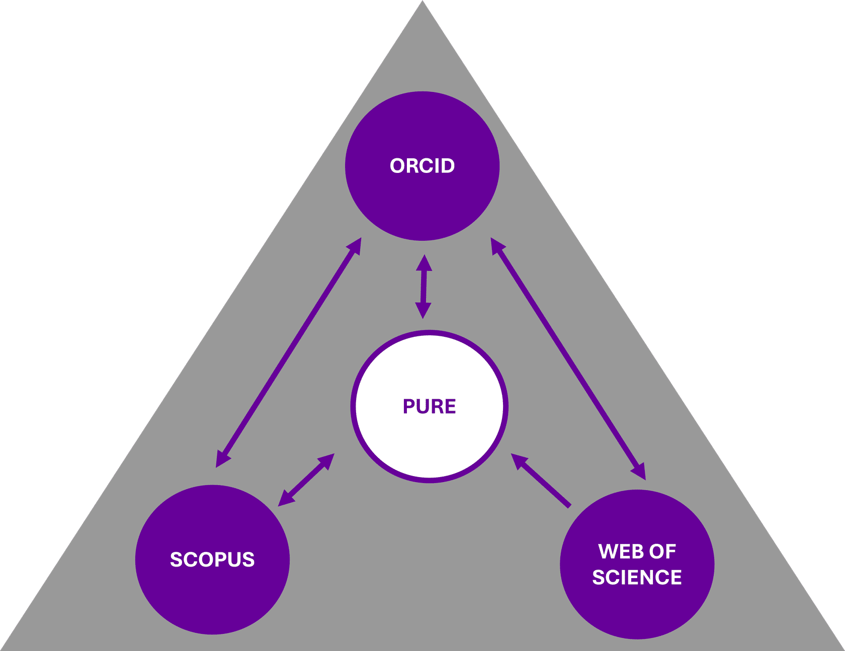

Ecosystem Components

Pure (Internal System)
Pure is the University of Manchester’s Current Research Information System (CRIS) and institutional repository for research outputs.
It acts as the University’s “single point of truth” for researcher information:
- Pure stores your ORCID, Scopus Author ID, and Web of Science ResearcherID.
- The identifiers recorded in Pure are used to support accurate internal reporting, REF preparation, School/Faculty analyses, and strategic planning.
- Pure is managed by the Research & Business Engagement (RBE) team.
- Keeping your Pure profile complete and accurate ensures your work is visible both internally and externally.

ORCID (Open, Non-Proprietary System)
ORCID provides a persistent, global researcher identifier that stays with you throughout your career—even if you change your name or move institutions.
It is an open, non-proprietary system used widely by publishers, funders, and universities.
ORCID helps your research “follow you” and plays a key connector role in the ecosystem:
- It links with Pure, enabling automatic updates.
- It links with Scopus and Web of Science, helping to synchronise works and identifiers.

Scopus (External System)
Scopus is Elsevier’s major abstract and citation database.
It automatically creates a Scopus Author ID and profile when your work is indexed—often leading to duplicates or missing publications unless reviewed.
Scopus is important because its data feeds directly into:
- QS World University Rankings
- THE Impact Rankings
Accurate Scopus IDs ensure correct attribution in these global evaluations.

Web of Science (External System)
Web of Science (WoS) is Clarivate’s major citation database.
It assigns researchers a ResearcherID and builds a profile that must be claimed and validated to ensure accuracy (green tick ✔).
WoS is significant for institutional visibility because it underpins:
- Highly Cited Researchers (HCR) identification
- ARWU/Shanghai rankings
Correct affiliations (“University of Manchester”) are essential for accurate credit.

Managing your research profile in Pure

What is PURE?
Pure is the University of Manchester’s central system for storing information about researchers, their outputs, projects, and activities. It is managed by the Research and Business Engagement (RBE) team and acts as the University’s “single point of truth” for research information.
For researcher identifiers:
- Pure contains dedicated fields for your ORCID, Scopus Author ID, and Web of Science ResearcherID.
- Recording these IDs in Pure ensures your publications can be accurately connected to you and attributed to the University.
- This is especially important for internal reporting and exercises that look at outputs across a School or Faculty (e.g. REF simulations, rankings analysis).
Key action: Check your Pure profile today – do all three of your IDs appear (ORCID, Scopus, Web of Science)?
- If yes: great, you’re fully connected.
- If No: use the relevant sections in this resource to claim, validate, and add them.
- Pure support via the Research and Business Engagement team

How to check your IDs in Pure
It only takes a couple of minutes to see whether your ORCID, Scopus, and Web of Science IDs are recorded in Pure.
- Log in to Pure
  - Go to the Pure login page.
  - Use your University credentials to sign in.
  - If you’re new to Pure or need help, see the RBE guidance on getting started.
- Check your profile
  - Click Edit Profile.
  - Scroll to the Identifiers section.
  - Look for entries for:
    - ORCID
    - Scopus Author ID
    - Web of Science ResearcherID
  - If all three are listed: you’re up to date.
  - If one or more are missing: use the guides in this resource to claim, validate, and add them.

ORCID: the connector in your Researcher Profile Ecosystem

What is an ORCID?
ORCID is your persistent researcher ID. It travels with you across publishers, funders and institutions, and helps systems recognise both you and your publications.

Why ORCID matters here
- It connects systems. ORCID links Pure ↔ Scopus ↔ Web of Science, so your outputs and IDs can sync across platforms.
- It saves time. Once connected, Pure can update your ORCID (and vice versa), reducing manual entry.
- It improves attribution. A linked ORCID helps prevent misattribution (especially with common names or name changes).

How ORCID fits with the other components
Pure: Connect your ORCID in Pure so Pure can push or update your affiliation and outputs to ORCID, and import any missing items back.
Scopus: Connect your ORCID to your Scopus Author profile to keep identifiers aligned and enable import/export of works.
Web of Science: Link ORCID to your WoS Researcher Profile (ResearcherID) to sync works and identifiers.

Quick check: Is ORCID Linked in Pure?
Check your ORCID ID is included when checking your IDs in Pure.

If you already have an ORCID but it is not present
- Click “Connect your ORCID iD” (or “Re-authorise” if prompted).
- Sign in to ORCID and authorise Pure.
- When asked, grant Read and Update permissions so Pure can keep your ORCID current.

If you don’t have an ORCID
- Click “Create your ORCID iD” in the same section and follow the steps (it’s free and quick).
- Then authorise Pure as above.
Finish
- In ORCID, add Other Names (e.g. previous or publishing names) and check your visibility settings (ideally set to Everyone for works or affiliations).
- Back in Pure, confirm your ORCID now appears under ID.
Tip: After linking, Pure can automatically push new outputs and your UoM affiliation to ORCID (and import missing items from ORCID into Pure), cutting your admin time.

Link ORCID directly to Scopus & Web of Science (Optional but recommended)

Scopus → ORCID
- In your Scopus Author profile, look for Connect to ORCID (often in profile settings/author details).
- Sign in to ORCID and authorise the connection.

Web of Science (Researcher Profile) → ORCID
- In your WoS Researcher Profile settings, choose Link ORCID.
- Sign in to ORCID and authorise.
Why do this as well? It gives the ecosystem multiple “paths” for syncing, helping keep everything aligned even if one system misses an update.

What to do if ORCID is missing in Pure
- Follow the Quick check steps above to create or connect your ORCID in Pure.
- Then use the Scopus and Web of Science sections of this resource to finish linking across all systems.
- Finally, refresh Pure (or check back later) to confirm your ORCID appears in the ID section.

Scopus: Author IDs and Profiles

What is Scopus?
Scopus is Elsevier’s abstract and citation database, widely used by publishers, researchers, universities, funders, and global rankings providers. When you publish in a Scopus-indexed journal, the system automatically assigns you an Author ID and creates a profile.
Learn more about Scopus.

Why Scopus matters
- Scopus automatically assigns you an Author ID and generates a profile when you publish in any journals it indexes.
- These profiles track your publications, citations and other metrics.
- Because they’re created automatically, errors can sometimes occur (mainly with duplicate profiles, missing outputs or incorrect affiliations).
- Scopus data is used directly in the QS and THE Impact Rankings, so keeping your profile accurate will benefit both you and Manchester.

What is a Scopus Author Profile?
A Scopus author profile is created when Scopus indexes your publications. Each profile includes:
- A unique Scopus Author ID
- A list of your Scopus-indexed works
- Metrics associated with your publications (e.g. Citation counts, SDG keywords)
- A list of your affiliated institutions (e.g. University of Manchester) and name variants
N.B. Because Scopus author profiles / IDs are created automatically:
- You may have multiple profiles / IDs
- Some publications may be missing or incorrectly assigned
You can use Scopus’s Author Feedback Wizard to merge duplicate profiles or correct your publication list. Please contact the Office for Open Research if you have further questions around duplicate profiles.

How do I find my Scopus profile?
To locate and verify your Scopus author profile, please follow these steps:
- Go to Scopus and access Author Search: Visit the Scopus database using the link available via Library search. Once you have accessed Scopus select the “Authors” search tab.
- Enter your details: Search using your last name and first name (or initials). You can also filter by affiliation (e.g. University of Manchester) or search using your ORCID.
- Locate your Author Profile: Browse any matching author profiles. Check the affiliation, subject area, and publication list to identify author profiles that correspond to you.
- Open your Author Profile page: Click your name to view your Scopus author profile, including your Scopus Author ID and citation metrics.
- Review and update your Author Profile: You should now verify that the publications listed under your profile are indeed yours and check for completeness. You can use the Author Feedback Wizard to:
  - Add or remove publications
  - Merge duplicate profiles
  - Correct your name or affiliation
Watch this short video on managing your Scopus profile.

Linking your Scopus Author Profile to Pure
Once you have located your Scopus Author ID, you should check that it is recorded correctly in Pure, the University’s research information system.

Why link Scopus to Pure?
Linking ensures:
- Automatic syncing of publications from Scopus into Pure
- Accurate tracking of citations and metrics for internal reports and ranking exercises
- Consistency is key to ensuring accurate reporting and visibility of your research outputs. Pure stores your unique identifiers, such as your Scopus ID, while ORCID acts as the central hub for cross-platform connections.
It’s important to note that Pure does not directly sync publications from Scopus or Web of Science to ORCID. Instead, Pure records these identifiers, enabling the University to track and report research activity effectively. ORCID is the system that facilitates synchronization between Scopus and Web of Science content.
By recording all identifiers in Pure, you help maintain a cohesive and reliable research profile ecosystem, ensuring your work is represented accurately across platforms

How to link your Scopus ID with Pure
The University uses Elsevier’s “Match Scopus ID” tool to automatically scan for Scopus Author IDs which belong to named researchers. However, this process is not perfect, you should always check the results. To check or add your Scopus ID in Pure:
- Login to Pure
- From the Personal tab, Click “Edit profile” under your name and photo (a new window opens)
- Scroll to the “Identifiers (ID)” section
When you look at your Scopus Author ID in Pure, you’ll usually find one of the situations below. Each has a straightforward next step.

No Scopus ID is present
If no Scopus ID is present within Pure then you should add it manually:
- Click Add ID
- Select Scopus Author ID
- Paste your 11-digit Scopus ID
N.B. Consult the How do I find my Scopus profile? section above for assistance with locating your profile ID.
- Set status to Verified

Scopus ID with a green tick
This means the Match Scopus ID tool has confidently linked your profile. Please verify that the ID number displayed next to the tick is correct by following the link through to Scopus and scanning the publication records. If it is incorrect please Contact the Office for Open Research for assistance.

Scopus ID marked as “Candidate for verification”
This suggests a possible match - this will require manual verification.
- You will need to check if the ID suggested corresponds with your profile. Clicking on the number will take you to the specific profile page in Scopus from where you can view the list of publications etc to assess whether the record belongs to you.
- If the suggestion is correct, then please click Mark as Verified
- If it is incorrect, click Edit to remove it and re-add the correct one manually (see step 1)
N.B. Consult the How do I find my Scopus profile? section above for assistance with locating your profile ID.

Multiple Scopus IDs present
This means you likely have multiple Scopus profiles. This can happen if you have published under different names, name variations (e.g., middle initials), or affiliations. Scopus automatically generates IDs based on publication records, and variations in these can lead to separate IDs.
You should use the Scopus Author Feedback Wizard to merge them:
- How to merge Scopus profiles
Once merged you should remove the redundant IDs from Pure using the Edit button.

Syncing Pure / Scopus data
After confirming your Scopus ID in Pure:
- Go to the Automated Search section in your Pure profile
- Toggle Scopus → ON
Pure will now regularly search Scopus using your ID and offer any new publications for review and import.
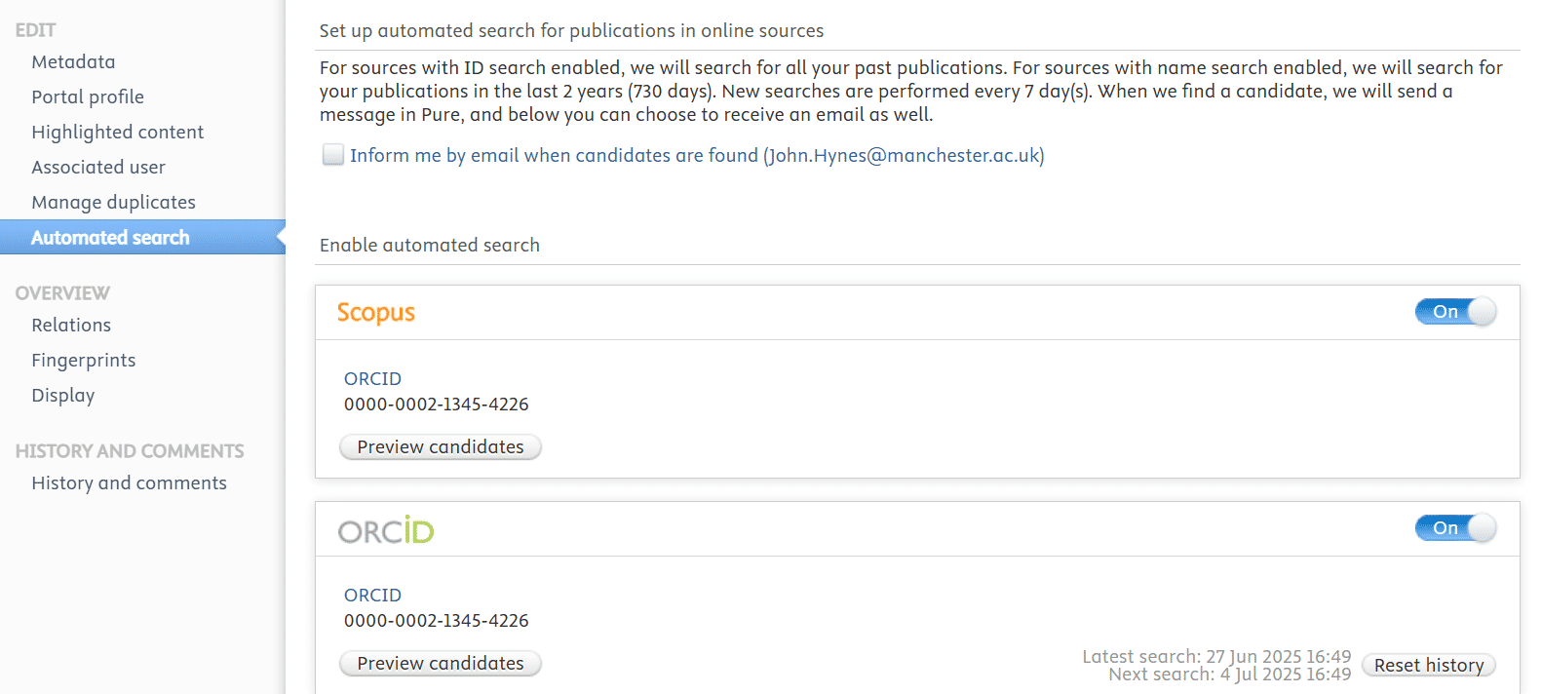

Web of Science: Research ID and Profiles

What is Web of Science (WoS)?
Web of Science (WoS) is Clarivate’s citation database, covering a wide range of journals and research outputs. It assigns each researcher a ResearcherID and generates a profile, which you can claim and validate to ensure accuracy.
Learn more about Web of Science.

Why Web of Science matters
- Web of Science creates a ResearcherID and profile to link your outputs in the WoS database.
- To control it, you must claim and validate your profile. Only then do you get the Web of Science green tick ✅ (showing accuracy and ownership).
- Affiliations are key: make sure “University of Manchester” is correctly recorded. This is critical for recognition in exercises like Clarivate’s Highly Cited Researchers.
- Unlike Scopus, Pure does not auto-match WoS IDs — you will need to add your ID manually.

What is the Green Tick in Web of Science?
The green tick appears on your Web of Science Researcher Profile once you have claimed and validated it.
- The green tick is visible within your Web of Science Researcher Profile.
- It confirms that you own the profile and that the information has been verified.
- A profile without a green tick has not yet been claimed and may contain errors.

How do you get the Green Tick?
To receive the green tick, you need to:
- Log in to Web of Science using your institutional or personal account.
- Find your Researcher Profile by searching for your name.
- Select “Claim my record” and confirm your identity.
- Review and verify your publications and affiliations.
Once this process is complete, your profile will display a green tick ✅ to show it has been validated.

Why the Green Tick matters
- It shows that your Web of Science profile is accurate and under your control.
- Validated profiles are used in analyses such as Highly Cited Researchers (HCR), which feeds into the ARWU (Shanghai) rankings.
- It reduces the risk of missing outputs, duplicate profiles, or incorrect affiliations.
After validating your profile (green tick ), you need to add your Web of Science ResearcherID to Pure so it is recorded centrally.

Checking your Web of Science Researcher Profile
What to do whether you already have a profile or need to claim one.

If you do

How do I manage and validate my Web of Science profile?
- Manage your publications
  - ✅Verify authorship: Check that all the publications listed within the profile are genuinely yours.
  - Add missing publications using the search/import tool or by linking to your ORCID.
  - Remove incorrect items or duplicates.
  - Merge profiles if you appear under multiple records (contact Clarivate support if needed).
- Set your institution correctly
  - Ensure your primary affiliation is listed as University of Manchester.
  - This is vital for inclusion in institutional counts like the Highly Cited Researchers list.
- Receive a “green tick” validation
  - The ✅ green tick confirms your identity has been verified.
  - Only you, as the profile owner, can make further edits.
  - If your profile lacks this symbol, it means that you still need to claim or confirm it.

If you don’t
If you don't have a Web of Science Researcher ID in Pure then follow these steps:

Step 1: Find your Web of Science profile?
- Go to Web of Science: Access WoS using the link available via Library Search. Sign in using your institutional or personal account. (If you don’t yet have an account, click Register and follow the prompts.)
- Search for your name: Use the “Researchers” search tab to find your profile. Enter your full name. You can use the Affiliations and or Web of Science Categories filters to help identify your profile quickly.
- Claim your profile: If a profile exists, click “Claim my record” at the top of the profile page. You may be asked to confirm some publication matches.
- Create a profile (if none exists): If no record is found, click “Create researcher profile” to set one up manually. You’ll be able to import publications and add your details.

Step 2: Adding WoS Researcher ID to Pure
Now you have located your Web of Science Researcher ID you now need to record this within Pure. Follow the steps below or watch this video on how to add your WoS Researcher ID.
- Log in to Pure
- Go to your Personal tab and click “Edit profile”.
- Scroll to the Identifiers (ID) section
- Click “Add ID”
- Select “WoS ResearcherID”
- Enter your full ID (e.g. A-1234-2025)
- Click Create

Step 3:Now manage and validate my Web of Science profile?
- Manage your publications
  - Verify authorship: Check that all the publications listed within the profile are genuinely yours.
  - Add missing publications using the search/import tool or by linking to your ORCID.
  - Remove incorrect items or duplicates.
  - Merge profiles if you appear under multiple records (contact Clarivate support if needed).
- Set your institution correctly
  - Ensure your primary affiliation is listed as University of Manchester.
  - This is vital for inclusion in institutional counts like the Highly Cited Researchers list.
- Receive a “green tick” validation
  - The green tick confirms your identity has been verified.
  - Only you, as the profile owner, can make further edits.
  - If your profile lacks this symbol, it means that you still need to claim or confirm it.
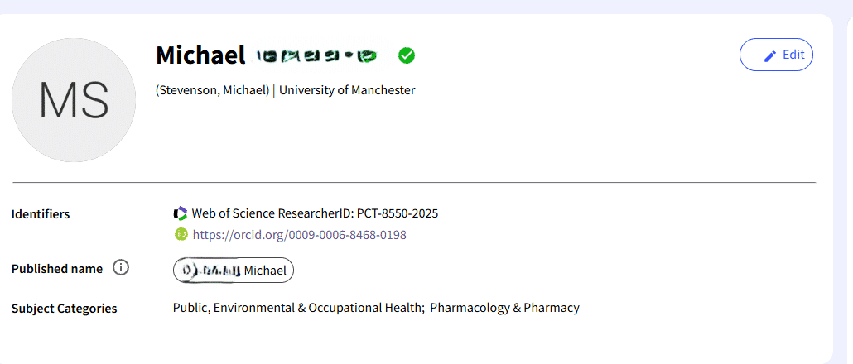

What to do if things don’t look right
- Haven’t claimed your profile yet? Log into Web of Science, search for your name, and select “Claim my record”.
- Multiple profiles? Merge these through WoS by following the on-screen options or contacting Clarivate support.
- Missing publications? You can add them manually through your WoS Researcher Profile.
- Affiliation incorrect? Update it so “University of Manchester” is listed.

Next Steps & Further Support
Now that you’ve checked and updated your researcher IDs in Pure, ORCID, Scopus, and Web of Science, there are several ways you can put them to use:

What you can do with your IDs

Request personalised metrics
Use the Research Indicators Gateway to request analyses such as:
- Citation counts
- Collaboration maps
- Contribution to the UN Sustainable Development Goals (SDGs)
These reports are generated using your identifiers, so accurate IDs = accurate metrics.

Simplify grant and fellowship applications
Many funders and publishers now require ORCID or accept automatic data imports from Scopus/WoS.

Showcase your impact
A clean, validated profile improves discoverability for collaborators, policymakers, and partners.

Keep your profile future-proof
With your IDs linked, new outputs can flow more easily across systems, saving you admin time.

Where to get help
If you encounter any issues when claiming, validating, or linking your profiles:
- Contact the Office for Open Research (Research Indicators team) for support.
- See our full set of step-by-step guides and FAQs on [Library Researcher Profiles Support]
- For issues specific to Pure (e.g. access or login), see the RBE Pure support pages.
Remember: Keeping your research profiles accurate and connected is not just about visibility today, it also supports Manchester’s ability to model performance in rankings, REF, and strategy.

