7 Steps to Maximise the Profile of Your Next Paper

Introduction

Promotion of your papers and research is very important. Even the most valuable pieces of academic work can become lost in the vast number of papers that are published each year.

This resource will guide you through 7 steps you can undertake to help you to maximise the profile of your work and ensure that work is credited to you correctly.
How much do you know about citation levels?
Standing out and being noticed is very important. Around 2.9 million scholarly articles are published each year. With this figure in mind, consider the following question:
What percentage of academic papers receive at least one citation in the first five years after publication?
45% of articles published in the top 4500 scientific journals are cited within the first five years of publication. With less than half of papers being recognised by peers, it is important that you maximise the profile and reach of your work.

Benefits of promoting your next paper
Promotion maximises exposure and will make your work visible to a wider audience.
Open scholarship provides the widest possible audience for all of your research outputs. This can include open access publishing, open research data, open educational resources, and open sharing of practice.
It has never been more important for research to have a positive impact beyond academia. Engaging online and promoting your work can help you to gather information on the impact your work has had.
By taking an active role, you can shape and control your online identity ensuring all your work is correctly attributed to you.
Actively promoting your work can help to get the conversation started around your paper. It can also connect you to other researchers in your discipline.

7 Steps
Below you can see an outline of seven steps which you may want to consider to promote your next paper.
In the rest of this resource, we will explore each of these steps in more detail.
- Think Open Access
- Claim an ORCID
- Explore altmetrics
- Engage with social media
- Blog about your paper
- Share your data
- Choose a homepage

Step 1: Think Open Access
Have you ever discovered a paper that sparks your interest only to find you need to pay to access it? Do not let somebody else have the same issue with your work.
Open Access (OA) means that items of scholarly work are made available online, in a digital format, at no charge to the reader and with limited restrictions on re-use.

Benefits of Open Access
- More exposure for your work
- Practitioners can apply your findings
- Higher citation rates
- Your research can influence policy
- The public can access your findings
- Compliant with grant rules
- Taxpayers get value for money
- Researchers in developing countries can see your work

Step 1: Methods of Open Access
There are two ways of making your work Open Access:

Gold
Gold Open Access is where the:
- final post peer-review version of a published work is freely available via the publisher’s website immediately on publication
- published work may be published under a Creative Commons licence
- publisher may apply an Article Processing Charge (APC) to cover publication costs

Green
Green Open Access is where the:
- published work is freely available via an institutional or discipline-specific repository
- version of work made available may be before peer-review (pre-print, draft) or after peer-review (Author Accepted Manuscript or publisher’s version)
- version deposited may be subject to a publisher’s embargo
- article is made Open Access without payment of an APC
To achieve Green Open Access you should deposit your accepted manuscript via the Library’s Open Access Gateway. The Library will then complete all checks necessary to ensure the paper is freely available to read and download. The Open Access funding page on the Library website explains the University’s Gold Open Access funds and eligibility criteria. To request payment of Gold OA publication charges simply check the relevant box on the Open Access Gateway form. Requests will be assessed based on eligibility criteria.
Step 1: Open Access in Action

Many people will be familiar with the idea of the paywall; you find an article you are interested in and discover you need to pay or take up a subscription to access the content. The University of Manchester provides its staff and students with access to a large collection of journal articles, e-books and other online resources. Unfortunately, others do not necessarily enjoy the same high levels of access.

A free service called OA Button will search the web for freely available versions of subscription-based research articles.

Take a look at the examples below to see what people could experience with your own work if you do not provide Open Access.

Article 1
For the article below you can see the paywall image someone may come across if your article is not Open Access.

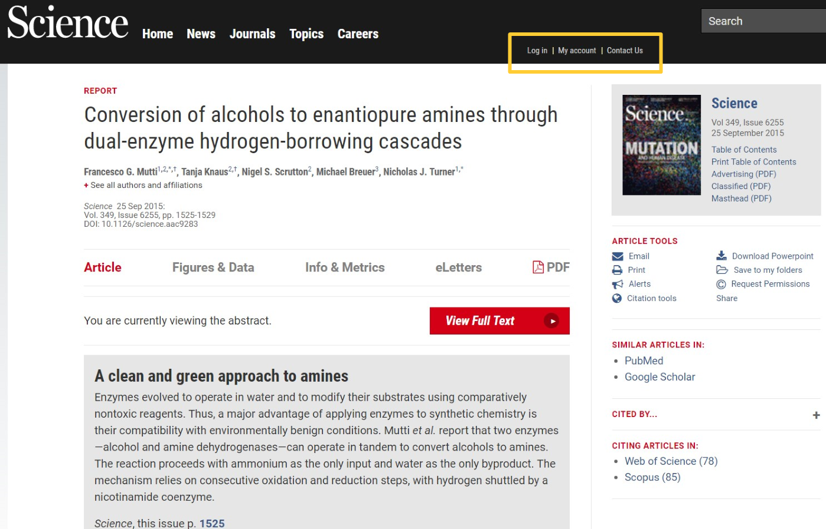

By clicking Open Access Button, you can view the Open Access version of the article.

Article 2
For the article below you can see the paywall image someone may come across if your article is not Open Access.

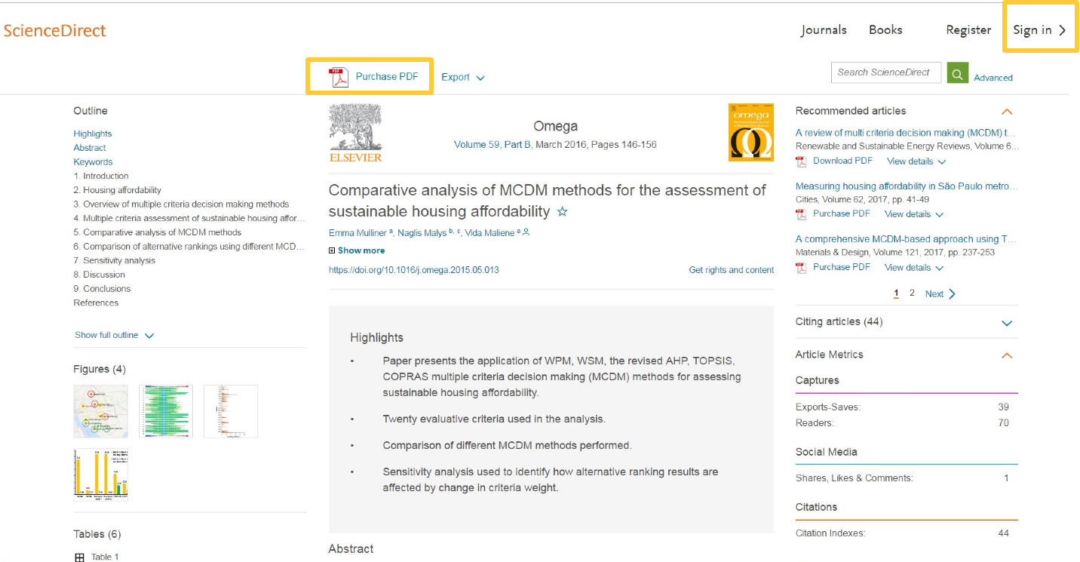

By clicking Open Access Button, you can view the Open Access version of the article.

Article 3

For the article below you can see the paywall image someone may come across if your article is not Open Access.

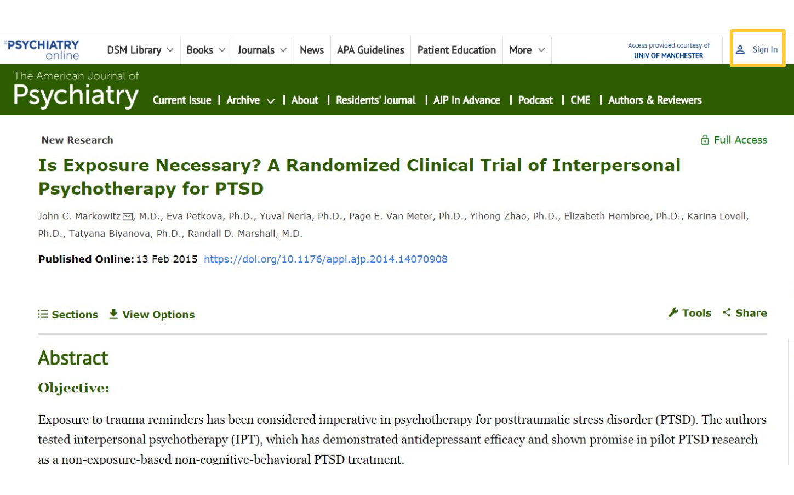

By clicking Open Access Button, you can view the Open Access version of the article.

Step 2: Claim an ORCID
An ORCID is a unique identifier which allows you to distinguish yourself from other researchers throughout your career. It is free to create and enables authoritative links to be created between you and your research activities.
This section will explore ORCIDs in more detail.

What are ORCIDs?
An ORCID account consists of two key components:
  - A definitive record of your research activities which is available to other systems via the open ORCID registry.
  - A personal profile page which is available via a unique URL.
This short video gives a good overview of ORCIDs.

Link your ORCID and University Account
If you undertake research at the University then you are expected to have an ORCID and link it to your University account. Depending on your role, there are different ways to do this:
Member of staff:
If you are a member of staff you should claim and/or link your ORCID via your Pure profile. You can then also create a link between Pure and ORCID which means that your research outputs in Pure automatically synchronize with your ORCID account.
Research student:
If you are a research student, then you should claim and/or link your ORCID via this dedicated page on the Library website.

Step 3: Explore altmetrics
This section will define what we mean by the term ‘altmetrics’, how they differ from traditional bibliographic measures, how to find and access them.

How are altmetrics different?
Altmetrics are new metrics that can be used to measure a paper's reach as well as being useful to support statements regarding a paper's non-academic impact. Altmetrics are often displayed alongside articles on publishers’ websites; this allows you to easily view the online discussion around the paper.
The highest profile services providing altmetrics are Impact Story, Altmetric, and Plum Analytics. Each aggregates some or all of the following types of activity:
- Scholarly usage data: Web-page views, PDF downloads
- Scholarly reference: Bookmarking, shares and recommendations from CiteULike, Zotero, Mendeley
- Mass media mentions: NY Times, BBC, The Washington Post
- Social media mentions: Twitter, Facebook, Delicious
- Data and code usage: Dryad, GitHub
- Component mentions: SlideShare, Figshare

Platforms that use altmetrics
Altmetrics are being utilised by many publisher platforms, see some examples below.
- Nature: Gives details of blog and social media mentions.
- Wiley Online Library: Gives details of social media mentions.

Altmetric data
The Library subscribes to a tool called 'Explorer for Institutions' that allows you to easily view the online attention to the University's research outputs. You will need to be on campus to access the explorer but by creating a personal account with your manchester.ac.uk email address you can then access the tool from anywhere.
The Library regularly runs a 'Who's talking about your research?' workshop which covers how altmetrics are being used by publishers, funders and research institutions, and how you can find out your own altmetric data.
You can find dates and book your place via the My Research Essentials page on the Library website.

Step 4: Engage with Social Media
Social media is a great way to promote your work and connect with others.
This section will highlight how social media networks can be used to increase awareness of your work.

Engage with Social Networks
Social networking is often only considered as being useful for our personal lives or as a way of keeping up to date with big news stories. However a growing number of researchers and academics are using social networks as means to stay up to date with new subject developments, to engage with the research community and to promote their own work.
The journal Nature published an article titled Online collaboration: Science and the social network by Richard Van Noorden. The article explored why scientists use social media.
- Twitter: is a micro blogging site used to send short messages of up to 280 characters which can include links, images, and videos. According to Noorden’s research the main reason researchers use Twitter is to follow discussions on research-related issues.
- ResearchGate: allows researchers to share publications, connect and collaborate with colleagues and gather statistics on who is reading and citing their work. According to Noorden’s research the main reason researchers use ResearchGate is to maintain a profile in case someone wishes to contact them about their research.
- Academia.edu: is a platform for academics to share research papers. According to Noorden’s research the main reason researchers use Academia.edu is to maintain a profile in case someone wishes to contact them about their research.
- LinkedIn: is a networking site aimed at professionals. It enables the creation of a profile which encompasses work history, expertise and accomplishments. According to Noorden’s research the main reason researchers use LinkedIn is to maintain a profile in case someone wishes to contact them about their research.
- Facebook: is a social networking site allowing users to connect with friends. According to Noorden researchers tend not to use Facebook professionally.

Impact on Paper Usage
Your use of Social networks can directly impact on the engagement and usage of your work. The chart in this blog post maps out full text downloads for a newly released article. Notes have been added to highlight key dates including launch and promotion via social media.
As you can see, there were almost no downloads until the writer began the process of self-promotion. You can see a direct correlation between social media activity and full text downloads.

Step 5: Blog about your paper
Blogging can vastly increase your discoverability. Blog posts are incredibly easy to share online via social networks.
Also, having an active blog with regular posts will ensure your webpage is noticed by search engines.

Why academics should blog
Take a look at this article and graphic from the University of Cambridge. We have highlighted some of the benefits that relate directly to promoting your research below:
- Thought leadership:
  - To build your reputation
  - To express your opinion
  - To create conversation
  - To promote a book, event or paper
- Community:
  - To build a community that comments and contributes.
  - To create a medium for social learning.
  - To enable a wider audience to take part.
  - To be part of the conversation.
- Audience:
  - To build your audience. Think about who else might be interested in your research, such as; students, other researchers, practitioners, policy makers, general public or businesses.
- Promotion:
  - To promote your own expertise and knowledge.
  - To support promotion of your faculty, department or school.
  - To support and encourage student recruitment.
- Network:
  - To connect with academics in your network.
  - To increase your social media following.
  - To create new network connections.
- Skills:
  - To increase your digital skills in writing and producing media for different audiences.
  - To learn and use new digital tools for working collaboratively.
- Stay informed:
  - To stay informed about the work going on in your wider network.
  - To read and discover new research which impacts your own.
  - To listen to other ideas and arguments.
- Disseminating research:
  - To link back to your underlying research paper or data.
  - To communicate your key findings using more accessible language.
  - To help shape your thoughts about your future research.

Post a blog about your paper
The Conversation is a blog which provides news, analysis and commentary that is produced in collaboration between editors and academics. As part of our institutional subscription, members of The Conversation's editorial team visit the University several times each year to run workshops covering how to pitch a blog post and tips for writing an effective blog post.
If you want to explore writing a guest post on an already established blog the Library can provide a list of blogs which regularly link to papers in your discipline. You can request this via email.
Writing for Research has useful advice on writing a blog post from your journal article.

Step 6: Share your data
Sharing your data can have benefits for yourself and other researchers. Having your data openly available also provides another route for others to discover your work.
This section will explore the benefits of sharing your data and will highlight some of the drawbacks you could experience if you don’t.

Benefits of sharing your data
Having your data openly available can have benefits for yourself and other researchers too, for example:
- Enabling collaboration: by making your research data more accessible to other researchers.
- Discoverability: The more places your data and work is available the easier it will be to find. Attaching a DOI to it makes it easier for researchers to cite your data and you can then track engagement with tools like Altmetric.
- Efficiency: Sharing your data will allow others to further develop the area of study without the need to recreate tests and studies.

Experience of sharing your data
We have now covered how it can benefit you to share your data.
Watch this video which highlights some of the issues that arise from data being managed badly and not being shared.

How can you share your data?
Sharing research data has numerous benefits including facilitating new collaborations and allowing new research questions to be answered. Data sharing is also mandated by many research funders and publishers.
Following the steps below will help make your data FAIR (Findable, Accessible, Interoperable and Re-useable) in line with the principles backed by Horizon2020 and academics across many disciplines.
- Prepare your dataset.
- Check your funder’s data sharing requirements.
- Choose a repository.
- Decide if your data needs to be restricted or embargoed.
- Upload your data and choose a licence.
- Add a Data Access Statement to your paper (if your data is connected to a paper) or publish a separate data paper.
- Record your data in Pure.
If you require any more information or guidance on managing your research data please visit the Research Data Management page on the Library website or contact us by email.

Step 7: Create a homepage
A homepage can act as your central hub, a place where you can provide links to all your online content.
This section will explore some of the benefits.

How a homepage can benefit you
Having a personal webpage has many benefits. Some of the key benefits are detailed below.
- Central hub: you can control all of your online content and drive it through your personal page.
- Everything in one place: you can link to all of your work, repositories, data, online profiles and social media in one place. Making it easy to find information quickly.
- Discoverability: having all of your information in one place makes all of your work more discoverable.

Case study: homepages
If you have a personal user account in Pure then you can enable your own profile page which is visible from the University's Research Explorer portal. It's easy to manage and you have complete control over which of your content in Pure is made visible.
Help on managing your Pure profile can be found on Staffnet.
Alternatively, about.me is a simple platform that allows you to make a basic webpage about yourself containing relevant links and content.
Below are links to some example pages provided by about.me.
- Blogger example page
- Startup example page
- Photography example page

Summary
The simple steps highlighted in this resource do not take long to implement and can help you to raise the profile of your next paper.
Remember controlling and managing your online presence allows you to drive traffic down the channels you want. It will also enable you to ensure all of your work is correctly attributed to yourself.
- Think Open Access
- Claim an ORCID
- Explore altmetrics
- Engage with social media
- Blog about your paper
- Share your data
- Choose a homepage

