Using Special Collections in your Work

# Introduction

Using primary sources and special collections in your work can help you gain a **better understanding** of your research area. It will help you to identify gaps in existing research and look at your topic from alternative viewpoints, meaning you produce a well-researched assignment.

In this post, we will look at how to **think critically** when using Special Collections items, so you can **analyse sources** in their appropriate context. This will allow you to apply new skills to your academic work.

**Please note:**This resource won’t help you to search or locate particular special collections. To learn more about this, [**take a look at our website**](http://www.library.manchester.ac.uk/special-collections)**.**

# What is critical analysis?

Thinking critically means examining concepts, ideas and arguments from all possible angles and taking an analytical stance to **evaluate** and **constantly question** what is being presented to you. It helps you to question assumptions and gaps in the information you’re presented with and to fit together (or challenge) other information, sources, or your own knowledge.

**💡 Tip:** Demonstrating that you can think critically and apply these skills will improve your marks in academic work, because it will help you to show original thinking in response to your assignments.

Critical thinking is about much more than academic work. It can help you to question any information you’re given and **make up your own mind** based on the evidence. This is very important to be able to tell what’s fake news, and which information you can trust far beyond your University career. It can also help you to argue more effectively to convince others.

# Critical analysis of special collections

Special collections Special Collections contain a wealth of primary sources which support our understanding of the world around us. A primary source is a piece of first-hand historical evidence or an original account of an event: these are normally records, rather than resources which try to answer a specific research question.

Secondary sources (such as textbooks, articles and academic works) are normally based on, analyse or consider primary sources to support their arguments.

Primary sources aren’t just relevant to the past: they inform how we think about the present, and the academic context in which you work. This is why it’s important to understand how to analyse them appropriately. You can use the same skills to analyse secondary sources, such as articles and other research you use for your own academic work.

Many primary sources have an inherent bias which you can identify by exploring the context of the source or comparing it with other sources. The bias might be trying to make you support a particular view or idea. The context includes simple factors such as when and where a source was created and more complex ones such as how an item was made, or what it was made from. It’s important not to simply accept the information a primary source seems to show you but compare this with other sources to better understand its context.

# Examining an item from our collection

Item 1: This handbill was produced in August 1819, a week before the Peterloo Massacre in which a mass peaceful protest in Manchester was violently dispersed by the yeomanry, on the orders of local magistrates.

***Can you tell:*** where it was written, who it is addressed to and what sort of behaviour it is intended to provoke? With this in mind, why do you think this handbill was produced and what does it tell you about Manchester in 1819?

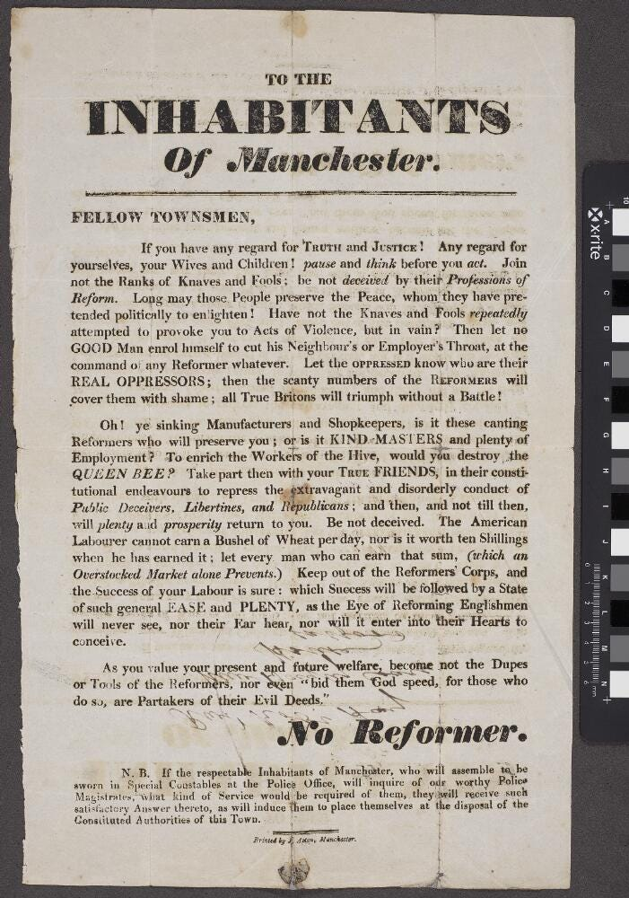

Item 2: Now consider this handbill, which was printed slightly earlier, in July 1819.

**Can you tell:** where it was written, who it is addressed to and what sort of behaviour it is intended to provoke? With this in mind, why do you think handbill was produced and what does it tell you about Manchester in 1819?

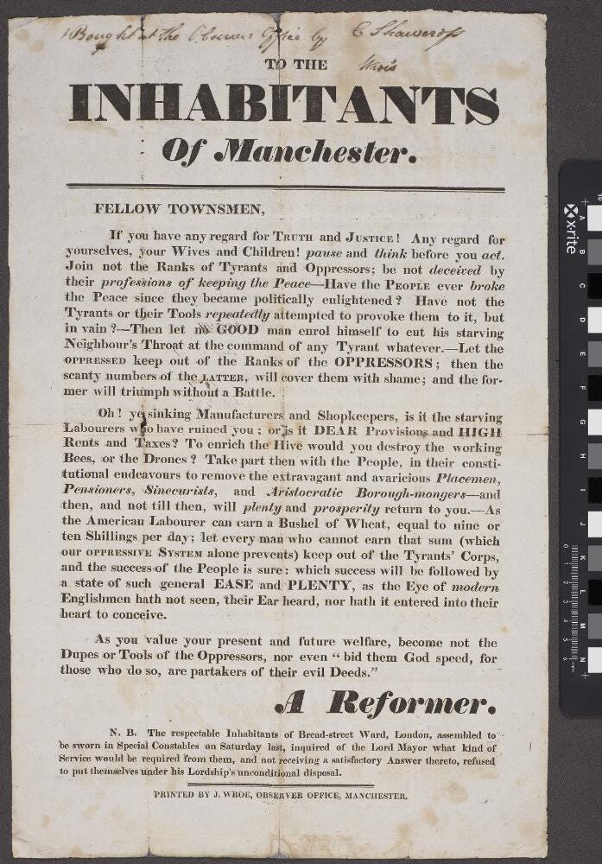

# Comparing different sources

Comparing these two sources, what are the similarities and differences between them?

You can see that they were printed by different people, with very different aims. If you had only looked at one and not investigated the content further, you might have thought that this represented all views in Manchester in 1819. It is always important to analyse your sources critically by asking questions.

Take a look at the **list of questions** below that you might want to consider when analysing sources for your work.

* Who was the author?
* Where is the text/image from?
* When was it written/made/published?
* What is it about?
* What does it tell you about the author’s or maker’s beliefs and ideas?
* What was the aim of the source? To inform, persuade, undermine?
* Why was it produced?
* Who was the audience?
* What’s the historical context?
* Why is it significant?
* How can you find out more?

# Summary

It is important to remember special collections can bring unique opportunities for you to explore new research as part of your work. They will also help you to develop and apply your skills in criticality, which is vital to ensure you are producing assignments of a high quality.