Strategies for effective group work

This blog post will look at various strategies you can use to help smooth the way into a great group work experience.

# Starting out

Your project is likely going to begin with a few big discussions. Getting equal contributions from all members of your team in this situation can often be a challenge. Some members of your team will be naturally more vocal than others.

While this can be helpful for preventing uncomfortable silences, it can mean that quieter members of your group can be put off contributing. There are some techniques that you can use to make all your team feel comfortable enough to get involved.

## Think, pair, share

Before discussing a particular problem or concept, ask all members of your group to think about it on their own for a short period of time. They can use this time to make notes. Then ask them to pair up with another group member and share their reflections. Each pair then shares their paired reflections with the whole group. This technique is effective as it ensures that every person will make a contribution but that no one is pressured individually to talk in front of the whole group. The thinking time beforehand also encourages reflection and careful consideration of the problem you want to solve.

## **Rounds**

Simply go round the group and ask everybody to speak briefly about the matter being discussed. It’s important to go round each member of the group, and everybody listens when it isn’t their turn. It can be useful to offer people the chance to pass their turn or to agree with something else that has already been said, in order to avoid putting people on the spot.

## **Jigsaw clustering**

This technique is mainly useful if you have a large group and/or complex problem. Divide your team into smaller groups and assign each group a particular element of the task you are working on. Allow a set time for them to discuss the problem, then time to prepare a short presentation back to the larger group about what they have discussed. This can be a great way to encourage more detailed conversations and provides a quick way to drill down into problems quickly. You could even extend this technique so that teams rotate through different problems and elaborate on suggestions made by previous teams.

Talking in big groups can be anxiety-inducing for a lot of people. Make sure everyone is heard and respected when they share their ideas. This should go without saying, but let’s say it anyway: Don’t laugh at, or belittle people for their suggestions, thoughts or ideas.

# **Time to delegate**

You’ve discussed your project and decided on a direction to go in, now it’s time to delegate. Group work can easily cause conflict, here are some of the potential pitfalls. Maybe you recognise some of these issues from previous group work projects:

* workload is not being divided equally.
* delegation occurs without discussion with the rest of the team.
* tasks are felt to be too easy or too much of a challenge.
* team members are only involved in tasks that are seen as less important to the final result.

All group members should feel able to raise concerns over task delegation. Try not to dismiss them because you ‘just want to get it done’. If you are flexible and plan out your project beforehand it will minimise these types of conversations and prevent later conflict which impact completion of the work.

**💡 Tip:** While you are contributing to group work, it is important to ensure that your contribution is distinguished from the contribution of others. **Failure to clearly differentiate your input can result in plagiarism**. Find out how to [avoid plagiarism through good academic practice](https://www.education.library.manchester.ac.uk/mle/avoiding-plagiarism/#/).

Remember group work is also about learning new skills and working collaboratively, not just completing the tasks before the deadline! One method for ensuring tasks are delegated fairly is to map them on a matrix. We will look at this in the next section.

## **Delegation matrix**

A matrix can be used in order to map out the key tasks, rating elements such as importance, time needed, and complexity. This will also provide a check so that members don’t end up with an unfair amount of work or complicated work. An example matrix is shown below. You may wish to adapt this according to the type of project you are completing.

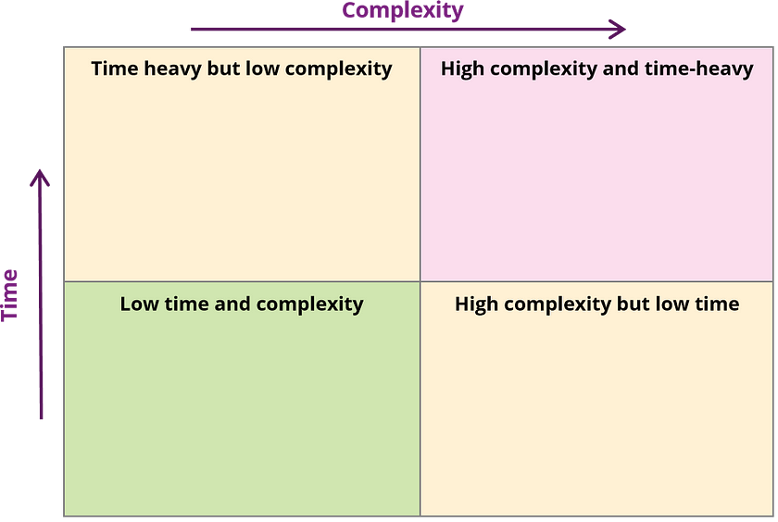

Image licensed CC-by-NC-3.0

## Make a plan

Creating a shared timeline of tasks is a great way of keeping track of your project. If you are using project management software to keep in touch, it’s likely that this is a built-in feature. Solutions like Asana and Trello are powerful, timesaving and can be listed as skills on your CV.

## **Creative a positive team culture**

Creating a positive team culture will help your group feel supported and able to raise issues quickly. To create a positive team culture, all members need to have responsibility, feel valued and have a shared sense of ownership. You are a team working towards one goal. Below are some questions you can consider as a group to ensure tasks have been delegated fairly.

* Do you feel able to complete your task?
* Will you need the support of any other team member(s)?
* Do you feel you are completing tasks which are important to the outcome?
* Have the tasks been distributed fairly?
* Do you feel able to raise concerns?
* Do the tasks you are completing provide you with an opportunity to learn or practice a skill?

If everyone can answer yes to most of these questions, your group will have the best chance of working well together, dealing with problems when they arise and importantly, feeling like the whole process is fair.

No matter how well you have planned your group project, it’s likely that at some point, things might feel as if they aren’t going as well as they could. This is normal when you are working with a large group of people. We’ll talk about this more in the ‘Challenges in Group Work’ section.

Group work can be challenging, however, it is great preparation for the workplace in which you will usually work as part of a team to complete projects or pieces of work. Learning to work well with others is a vital skill that any group project will help you develop, even when it goes less than smoothly. Don’t forget to download our templates at the end of this post.

# Starting work

Tasks have been delegated and it’s almost time to get started on actually doing the work. Before you do that, maybe your group would benefit from stating your intentions. Below is an example that should work for most group projects. If you’re all on the same page before you start, then that can help mitigate problems further into the project.

## How we intend to work

An effective group is about its culture and the behaviours its members display, rather than anyone’s personality. As members of the group we will all be responsible for:

1. Ensuring we each understand the aims of the group and what is required for it to be successful.
2. We will be accountable for completion of own tasks and responsibilities on time and keeping the rest of the group informed of our progress.
3. We will support each other as members of the group by sharing our knowledge, experience and time when support is requested. We will also ask for support where we need it.
4. We will communicate honestly and tactfully, and where issues or conflict occur work to find a collaborative solution.
5. We will divide tasks and responsibilities equally; ensuring fairness of workload and variety of tasks.
6. We will attend group meetings as agreed as a group, providing progress or updates to the group before these meetings when it is not possible for us to attend. We recognise that everyone’s time is just as important as our own.

This might seem like a lot of preparation when you all just want to get on with it, but the time you spend preparing is designed to speed up the process down the line. There are no shortcuts in group work, but you can get better at it and these techniques will become easier to implement the more often you use them.

# Challenges in group work

Tasks have been delegated, work has started and next come the problems. Issues and challenges are normal and expected, no project will go 100% smoothly all the time. Open and honest communication focussed on identifying solutions will help get things resolved, and this is where you’ll be thankful you spent time preparing.

Don’t be discouraged if things start to get off track. These are exactly the sort of challenges you are likely to face throughout your working life. Try to see it as an opportunity to develop your problem-solving skills, this is the kind of thing that happens often in the workplace, and these skills are valued by employers. Everything is a potential answer in a future job interview.

When problems do arise, the important thing is not to blame any particular group member. This is difficult because maybe it seems like it is actually someone’s fault, but placing blame doesn’t solve the problem and that’s your primary goal. Try and shift perspective from frustrations about people or personalities, to how the resulting problems can be fixed. For example, a team member might say “Alex took too long to complete their tasks and now we’re a week behind”. Rather than blame Alex, try to figure out what the result is. In this case, it’s that the timeline is delayed, so your team would need to work together to figure out how that can be fixed — and how it can be mitigated in the future.

1. Take some time to **understand the problem**, is it essential to sort out? What will happen if you don’t resolve it? It can be easy to lose sight of the original plan when something goes wrong. At this point, it’s important to check back against the assessment criteria and your group plan.   
   **TIP!** It is important to remember everyone is different. Listen to people’s issues and concerns, even if they don’t seem relevant.
2. Arrange a **discussion of potential solutions,** include their positives and negatives. You will need to decide if the whole group needs to be involved based on the size and impact of the problem. Communication is key here. Make sure the rest of the group is informed. If you are discussing issues as a whole or large group, make sure the conversation stays focused on the solution, and definitely don’t assign blame.
3. **Agree a solution and adapt your plan**. Doing something differently may require you to adapt your plan, if this affects you as an individual try to be flexible! It also may create new tasks, so make sure you factor this into how fairly the workload is divided.

## **We’re not going to finish on time?!**

Issues relating to deadlines are common, especially where there are interdependent tasks being completed by different people. If someone isn't meeting deadlines rule number one is **don’t place blame**. Instead offer support, ask the individual what they think is the issue is there anything else they need to know? If you’re having issues completing tasks on time, make sure you’re updating the team plan and remaining in communication with your team if things are taking longer than anticipated. This can be daunting, but being honest is the only way that things will get fixed.Take a look at this [guide to procrastination](https://www.education.library.manchester.ac.uk/mle/counselling/procrastination-strategies/) to understand why you procrastinate and practical strategies that you can use to overcome it.

As well as this piece of group work, remember you each have other demands on your time including individual assignments, work or personal commitments. Watch out for your fellow teammates and check in on their wellbeing, make sure no one is feeling overwhelmed. Keep checking that your plan is up to date. This is especially important where there are tasks which are dependent on others.

As a group check your plan regularly to see upcoming deadlines and remember not every task will be as interesting as another, however they do need to be completed.

# In summary

Group work can be fun, tiring, interesting and frustrating, but regardless of how your project works out, all the experience you gain makes a great answer in a job interview. Communicating clearly, task delegation, project management, conflict resolution – all of this is essential in a workplace and you will certainly be asked about your experience in some or all of those areas when you start interviewing for jobs. Good luck!