Advanced search: making use of Boolean operators

This guide gives an introduction to Boolean operators to help you find the most relevant results.

# Introduction

Your ability to search effectively for information is vital to find the best resources for your work. The use of operators in your searches such as Boolean and proximity can help you to broaden or narrow your search to the most relevant results.

In this post we will look at several of the most common search operators and how they affect the number and types of results that will be returned.

Tip: Before you read this post you might find it helpful to have an awareness of the databases most commonly used in your subject area; you can find them in your [Library subject guide](https://subjects.library.manchester.ac.uk/?b=g&d=a).

# **Key terms**

Throughout this post we will be using a number of words you will need to be familiar with. Take a look at them below:

* **Terms:** refer to the individual words you are searching for.
* **Operators:**refer to the symbols or words you can use to increase/reduce your search results to provide you with the most relevant results. Outside of this post you also may see them referred to as ‘**modifiers**’.
* **Search query:** Search query refers to the whole of your constructed search, including the individual terms and operators. Outside this post this will sometimes be referred to as your ‘**search string**’.

**💡 Tip:** It’s good practice to place operators in capital letters to make them more identifiable.

## Topic example

This topic will include examples and activities related to heath & medicine. The research question we will look at is:

“Discuss the implications of hearing impairment on a child’s ability to learn in a classroom/school environment”

## What is Boolean logic?

Boolean logic takes its name from its inventor, George Boole, an English Mathematician who pioneered the usage of the words **AND**, **OR**, and **NOT** to write computer programmes and isolate key pieces of data within them.

In this section we will look at how the application of Boolean logic in your search strategies will enable you to steer your search into the research areas you are interested in. It will also enable you to take more control over the range of search results you find.

**The AND operator**

Boolean logic enables you to manipulate and streamline data. The first part of Boolean logic we will look at is the **AND** operator. **AND**is used between two terms to join them together. For example: hearing impairment **AND** education. **AND** narrows a search because only results with terms joined by **AND** are retrieved.

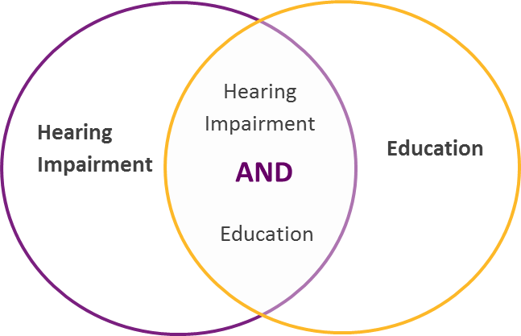

You can use **AND**as often as you like but remember the number of search results will reduce with each use as all of the terms joined by **AND** must be present in the results returned. Only use **AND** to combine terms representing different concepts.

Errors can often occur when **AND** is used where it isn’t needed. This is a common mistake which occurs when you think about your search terms as a list.

Such as, when listing all the of the words associated with hearing impairment you may think of:

* hearing impairment
* hearing loss
* deafness
* deafened
* partially deaf
* hard of hearing

When reading a list you may automatically say **AND** between each item. However, databases will interpret any occurrence of the word **AND** literally. Boolean logic determines that all terms joined by **AND** must be present.

**The OR operator**

**OR** is another Boolean operator. It is used between two search terms or phrases to expand the search. Where we used the **AND**operator in the previous section it was to only see results which contained both terms. Using the **OR** operator between terms will mean we **also** receive results which contained only one of our search terms.

Here’s an example of the **OR** operator in action:

When you search for ‘hearing impairment OR education’ you have three outcomes:

* results that are exclusively about hearing impairment
* results that are exclusively about education
* results that contain both hearing impairment and education

**OR** is useful to batch together similar terms. Especially when it doesn’t matter which term appears.

For example, the researcher may have wanted any variation of hearing impairment so his search could be:

Hearing **OR**Deafness **OR** Hard of hearing

This search would then return any result containing hearing impairment, deafness or hard of hearing.

**💡 Tip:** You can use **OR** as often as you like but remember the number of search results will increase with each use.

# The NOT operator

**NOT** is the third Boolean operator you should be aware of; it is used to exclude terms and reduce the number of results.

**NOT** is most commonly used to exclude a term that can infiltrate a search query because it may be related. It is important to note if one of the other terms is present along with the item excluded the result will still be displayed.

For example: if we wanted to search for ‘hearing impaired **OR** deafness but **NOT** profoundly deaf’, the following results would be returned:

* articles containing hearing impaired
* articles containing deafness
* articles containing both hearing impaired and deafness
* articles containing both hearing impaired and deafness that also mentioned profoundly deaf.

Results that contain only profoundly deaf but not hearing impaired or deafness would be omitted.

## What next?

When you move onto combining all three Boolean operators, things can get much more complex. Take a look at the ‘[Advanced search](https://medium.com/specialist-library-support/systematic-search/home)’ section of the publication for further help.