Revision Strategies

# Introduction

Effective revision is vital to exam success. There are many ways in which to revise and learning which techniques work best for you will help to reduce your stress levels during the revision period.

In this resource, we will introduce you to strategies which can help you to prioritise, plan, and memorise your material, and communicate your ideas.

Try out a range of these strategies in order to find those that work best for you! This resource will help you to create an effective revision plan and highlight key points to consider when developing your revision toolkit.

It is never too early to start revising. To get the most out of this resource complete all sections before getting started.

# Getting started

If you are already part way through your revision and your exams are fast approaching, you may find it useful to start at the section of the resource which best matches where you are in the process.

1. Prioritise
2. Plan
3. Memorise
4. Communicate

## Step 1: Prioritise

In order to ensure your revision is meaningful and relevant, it is crucial that you allow time to identify important topics and themes for your revision. After all your topics have been identified, you will need to assess each one and prioritise in order to make the most effective use of your time.

This section will help you to identify revision topics and current themes from your course material and decide where to focus your efforts. It will also suggest methods you can use to prioritise your topics to ensure you revise efficiently.

Firstly, lets identify all the possible topics that could be covered in the exam.

For some courses and modules, your topics for revision might be very clear. Other assessments may require more thought in order to identify what you need to revise. Below are some examples of places you can search for revision topics.

1. Course outlines, objectives: Course outlines, objectives or handbooks will highlight overall aims and objectives of your course. They can suggest the overarching themes/topics you should be covering in your revision.
2. Assessment overview, marking criteria: Assessment structure will inform you how much grading weight each assessment or exam carries. This can help you to plan your revision accordingly, allotting more time to areas which are worth the most.
3. Previous assignment feedback: Revisiting your old assignments and any feedback you received is a good way to refresh your knowledge of previously covered content. Feedback can help you to identify any areas of concern that you need to address.
4. Individual exam/assessment outline: Assignment/exam criteria may suggest the topics that will be covered.
5. Past papers: Past papers will help you to work out how many topics you need to revise for. They can also help you to familiarise yourself with the format of the exam and give you a sense of the type of questions you will need to answer so that you can prepare adequately.
6. Lecture notes: Lecture notes/slides are a great place to find topics for revision as the main areas or themes are likely to have been talked about and emphasises during lectures.

# Knowing where to start

When you are revising, it is easy to panic and jump straight in, often ending up spending a lot of time on your favourite topic whilst ignoring others. If this happens, you should try and take a step back and consider your priorities carefully.

## Do you feel confident about the topic/area?

If you feel fairly confident about a particular topic, it might be more beneficial to devote your time to an area where you feel less confident first.

If you know that there is something you struggle with or a topic which you missed the lectures for then fight the urge to bury your head in the sand and start your revision there to ensure you make the progress you need.

Working this way from the start will allow you to address known issues while you still have time and avoid stress that could result from procrastinating. Why not try a practice or past paper before you start your revision? This will help you to identify gaps in your knowledge.

## How many marks is it worth?

Understanding the grade weighting of an exam or assessment is useful when prioritising your revision. If an assessment is worth a large proportion of your overall grade for that module, the time you spend revising should reflect this.

## When are your assessments?

If you have assessments, spread out over the course of a few weeks, you may wish to prioritise those you will complete first. You can re-prioritise your schedule as you progress through your assessments.

# Using KWL

[‘Know, Want to Know, Learned’ (KWL)](https://mlemanchester.medium.com/making-notes-with-kwl-8e6fc34715f2) is a strategy where you map out what you already know, identify what you still need to cover and summarise what you’ve learned in the process. KWL is an effective strategy that can help you to identify your reading goal and read with a purpose. Simply make three columns on a page and follow these steps.

A blank template of the below table can be found at the end of this resource.

## Step 1

In column 1 you should review and record what you already **know**about the topic:

* What have you read or heard about this topic already?
* Can you summarise the main points or issues about the topic?
* How much detail can you go into? Can you identify key theories/models/data related to the topic?

## Step 2

Now you need to reflect on where you need to learn more. Analyse what you know and pinpoint the gaps in your knowledge so that you can address the areas where you need to focus your revision.

Ask yourself the following questions:

* Are you reading to understand and contextualise a topic/area?
* Are you reading to identify pertinent data/methods/research or evidence?
* Are you reading to deeply understand details?

In column 2 you can outline **what**you want to learn by writing a revision goal.

In having a clear understanding of why you are revising you can be sure that you are going to know when you have met your goal.

## Step 3

Select your revision to meet the reading goal you identified.

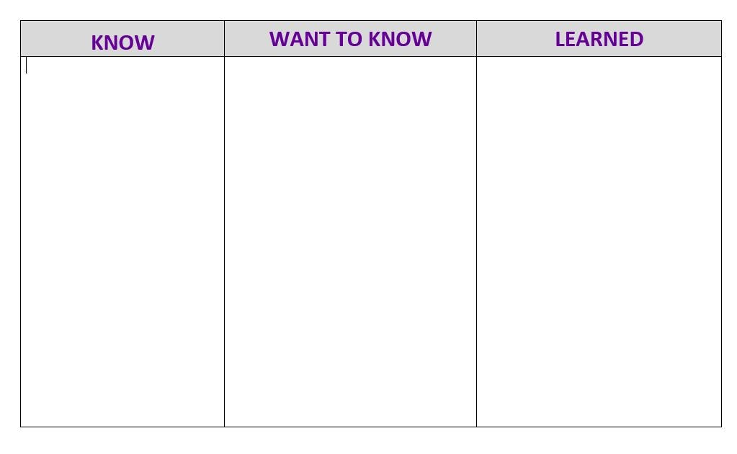

# Urgent/important matrix

You can also use the urgent/important matrix to prioritise both your revision and your everyday tasks. Draw out a 2 by 2 grid, with “urgent” and “not urgent” across the top of the two columns and “important” and “not important” down the two rows.

## The Urgent/Important quadrant

In this quadrant of your matrix, write down the tasks that are both important and need to be done soon, e.g. an exam which is this week.

## The Urgent/Not important quadrant

Here, you note down tasks which are urgent but not important, and can be delegated if possible. Alternatively, find ways to complete these in the most efficient way possible, so they don’t get out of hand and distract you from your revision.

## The Not urgent/Important quadrant

In this quadrant, you monitor tasks which are important but not urgent. Find time to complete these in the most efficient way possible before they become urgent.

## The Not urgent/not important quadrant

In this quadrant, note down trivial tasks that don’t need to be done in any rush. You should build regular breaks into your revision schedule but otherwise avoid tasks which are neither important nor urgent.

# Planning

It is never too early to plan for your revision. Start by using effective note making strategies and thinking about how you want to revise early in the semester.

This can save you a lot of time when you actually come to carry out your revision! Clear, organised notes also make much better resources for your revision. For help with note-making, check out [our guide to this topic](https://www.education.library.manchester.ac.uk/mle/note-making/).

To help you make progress with your revision, it’s a good idea to create a revision plan/timetable. This will help find time for learning outside of your lectures and seminars.

In this section, we will introduce you to revision planning strategies.

## Creating a plan

Revising in short bursts and spreading your revision over a longer period is far more effective than cramming. It will also enable you to keep calm, stay refreshed and sustain your motivation! Planning your revision in this way is sometimes referred to as ‘spaced practice’.

Below is an example revision plan where a spaced practice approach has been applied. A blank template of the below plan can be found at the end of this resource.

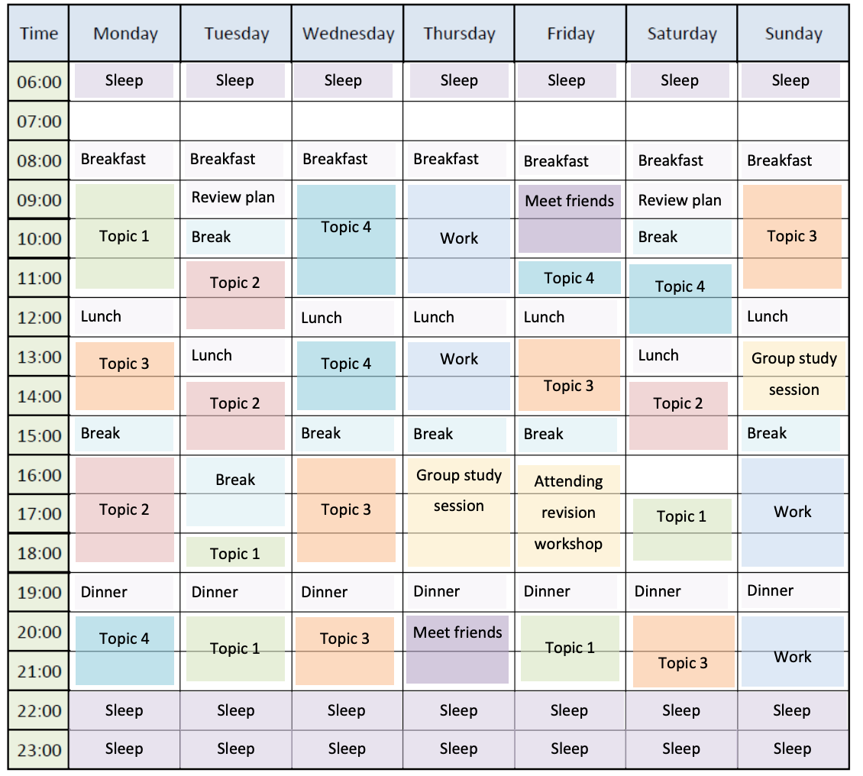

## Considerations

When planning your revision, it is helpful to consider the points below.

### When you work best

Are you more productive in the morning or the evening? Consider what time of day you are at your most productive and try to plan your revision for those times.

### Where you work best

Do you prefer to work in the privacy of your home or a public place like a coffee shop? A good thing to consider here is noise levels. Some people need silence, others concentrate better with background noise.

If your chosen location is some distance away, you may need to take travel times into account.

### Standing commitments

Do you have any commitments you need to continue through your revision, such as private appointments, sporting fixtures, events, work, or seeing friends and family?

It’s a good idea to minimize any other stresses during exam time and decide beforehand what you will take time out of your revision schedule to do and what you will leave until after you have completed your assessments.

### Build in breaks

Ensure you give yourself some time to take a break and relax. You need to take time out to digest the information you are consuming.

It is also a good idea to exercise (get some endorphins and relieve stress) or get fresh air.

### Food, drink, sleep

Looking after yourself is really important. Make sure you get enough sleep, eat healthy food and drink plenty of water. You could make batches of healthy food in preparation for the exam period. Staying hydrated helps.

## Planning tools

There are a lot of online tools available to help you plan your time. The benefit of using an online tool or app is that you can access it from anywhere and update it easily.

If you are viewing this resource on any device, click on the tools below to find out more:

* [The Student Room – Get revising](https://getrevising.co.uk/) – This website is useful if you like to plan out how many hours you want to spend each day/week on each task and make a schedule around your commitments.
* [GoConqr](https://www.goconqr.com/) – This website is useful for collating your notes, making mind maps and generally combining your revision information. It does allow you to create a schedule but it is not as flexible as some of the others available.
* [The Student Room – Smart Planner](https://www.thestudentroom.co.uk/g/planner/) – This student room smart planner has been designed specifically for revision. It allows you to block out other commitments and has a useful reminder feature to help you stay on track

Now it’s time to start planning! Feel free to use the blank templates at the end of this resource!

# Memorise

The following section will give you some ideas for revision activities that you can try to improve the way that you memorise information.

In your revision plan, allocate time to practice recalling and using information you have learnt.

This is scheduled time which you will use to recall the material that you have covered recently alongside older material. Depending on your preference, you might remind yourself about your course content by making flash cards, drawing mind maps, or with a variety of other techniques. This method of practising recalling content that you have memorised is known as retrieval practice.

In this section, you will explore approaches to committing information to memory which allow you to not only repeat what you have learnt but also adapt and reprocess your knowledge for different contexts.

Retrieval practice will help you to deepen your understanding of the subject as well as commit knowledge to your long-term memory. During these sessions, spend time practicing retrieving the content and testing yourself.

As you progress, repeat this method of recalling the same information with longer intervals between each recall. You might want to use notes to prompt you at first, then move to using flash cards, and finally, try to recall information on a specific topic without using a prompt.

By practicing recalling specific information for a purpose, or to answer a question, you are preparing yourself for what you will have to do in the exam, making it more likely that you will be able to access the information that you need, when you need it.

## Retrieval strategies

There are a wide variety of ways that you can practice retrieving your knowledge. We will look at some in this section.

### Flash cards

Flash cards are a great way to test your knowledge; you can use them to identify gaps in your knowledge or to help you to remember key details. On the flash cards you may want to include:

* Practice exam questions.
* Specific questions around each topic.
* Formulae/key terms that may come up during the exam.
* Colour-coded diagrams – use this technique if you need to identify each element or part of an overall process or diagram.

Each card should include only one question or challenge with an answer on the other side of the card. You can include multiple copies of a card in your set for topics you are struggling with.

**Tip:** You can use flash cards for a quick 5-minute challenge, alone or as part of a group study session.

### Past papers

Practice answering past exam questions using past papers. Using past papers will help you to:

* Recognise how questions will be phrased on your exam papers.
* Understand how to break down each question, making sure you will answer all the component parts.
* Communicate your ideas effectively to answer a set question.
* Identify gaps in your knowledge and generate revision priorities.

### Self-quiz

Create quizzes and use them to test yourself on key revision topics and themes. You will find it most useful to create quizzes using different types of questions, such as multiple choice, essay answers and true or false.

You can ask questions more than once but in a different way, prompting you to review all perspectives on a topic. Consider different language or phrasing to make sure your quizzes challenge your understanding of the subject as well as supporting your memorisation of the information!

**Tip**: Why not ask other people on your course to contribute questions and share your quiz questions with them? This will help you build up your bank of questions more quickly and help make sure you don’t miss anything out.

### Study groups

Study groups are a useful way of revising. They allow you to discuss and check ideas with your peers and can help to make the process of revision more interesting and keep you motivated. You can also use them to talk about topics you are struggling with, plus answering questions from others will give you practice in communicating concepts and ideas.

Don’t forget you can make use of your flash cards or quizzes during your group revision sessions!

**Tip:** Agree before a group revision session what you each want to get out of it. If you want a quiet space with your peers close by it will help if everyone knows before the session. You can make use of tools such as [doodle](https://doodle.com/en/) to find the best time for everyone.

## Quiz cards

As you revise, make sure you practice retrieving more than just words and theories. Look at the finer details of your topic and allow time for you to elaborate on and explain your understanding. This will ensure you identify and create connections between topics and ideas as you progress. One strategy that can help you with this is Quiz cards. Quiz cards are like flash cards, but include a couple of extra features:

* **Colour code your questions**. Then, when you test yourself, ensure you aren’t mixing up knowledge checks for material you’ve accessed more recently with materials you haven’t seen for a while.
* **Write out multiple questions** on the same topic or subject area, each requiring a different level of detail or perspective. This will require you to retrieve and recall the same knowledge with different prompts.

Using quiz cards will ensure you are able to apply what you have learnt in response to different tasks and contexts. Following retrieval sessions, make sure you always go back to your notes to check your responses. You can then access what you need to explore and elaborate upon during your study time.

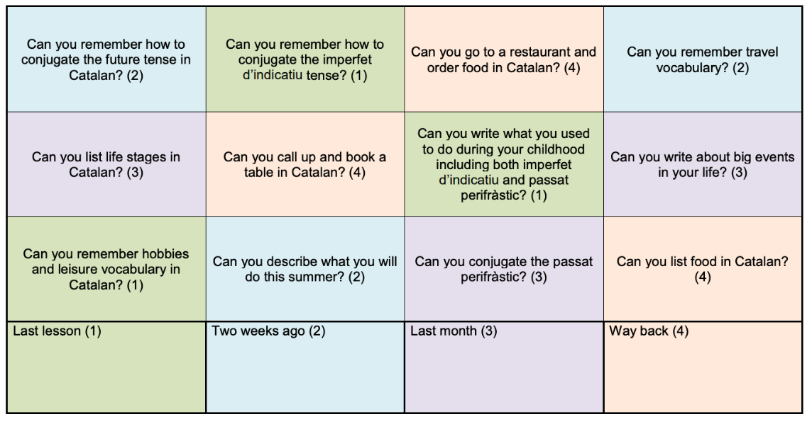Here is an example of a quiz card you could make:

## Mixing it up

There is evidence to suggest that you should mix up the topics that you study. Spend some time working on retrieving information in one area and then transition to another within the same study session. This is sometimes referred to as interleaving.

Mixing up topics like this allows you to make connections between different topics as you retrieve the material. It may help to change the order and combination of topics you are revising each time you study.

Add any new connections you identify to a revision mind map to help you remember why you think they are connected.

# Communicate

When revising to communicate, the objective is to gain a deeper understanding of your topic and the connections between different themes and ideas, allowing you to communicate your arguments more effectively.

Remember, you are not being assessed on the amount of information you have learned. You are being assessed on how effectively you communicate what you know to answer the questions set on the exam.

Practicing this type of revision will ensure you stay focused on the question rather than simply writing down everything you know about the main question topic.

This section will introduce you to various methods and techniques which you can use to practice communicating what you’ve learned from your revision.

## Study groups

Group study sessions can be a very effective tool in helping you to communicate your understanding of the subject area. Working together to share ideas and concepts will help you practice communicating what you know. They can be especially useful for dealing with detailed and complex information, where you know the ‘what’ but struggle to explain the ‘how’ or ‘why’.

One way you can structure your group study session to help you practice communicating your knowledge and ideas is for each member of the group to take turns explaining a topic. This will help you to; explain your key points clearly, structure your answer and reflect on your argument. Plus, if anything is unclear, your peers can ask you questions and further improve your skills in this area.

As everyone has their own strengths and weaknesses, this will aid both your revision and theirs.

## Past papers

Having a go at answering past papers will help you to become familiar with the structure and content of the exam questions you are likely to face and will allow you to practice answering questions in a clear, comprehensive and structured way.

If you don’t have time to practice completing a paper in full, planning answers to a selection of past papers is also very beneficial. It gets you into the habit of creating an essay plan and drawing together pieces of relevant subject knowledge in order to answer a set question, highlighting any gaps in the process. Look up past papers for your course and practice planning answers for each one, even the questions which you don’t think you can answer!

You will often be surprised at how much you can come up with; plus this technique is also a good way of 3pinpointing areas which need more work/research.

When planning your answers to pass exam questions you can practice using a *Question Matri*x to help you structure your argument and ensure you answer all parts of the question.

## Mind maps

Mind maps are useful if you want to find out how much you can remember on a topic. Creating a mind map is a great way to visualize your topic as it allows you to see the topic as a whole. It can also help you to make connections between different themes.

Use colour-coding to help you group themes and ideas together.

Check out mind-mapping software such as:

* [Freeplane](https://docs.freeplane.org/home.html)
* [MindGenius](https://www.mindgenius.com/)

All PCs on campus have the mind mapping software [Mindview](https://www.matchware.com/mind-mapping-tutorials) installed.

# Summary

Revision is an evolving process; remember to revisit your plan to check your progress and adjust your priorities as your exam dates get closer.

It is never too early to start your revision! If you don’t have any exams coming up, use your time to organise and review your notes in order to embed and develop your understanding.

As well as trying out some of the strategies in this resource, you may find it helpful to listen to our [revision support podcasts](https://soundcloud.com/uomlibrary/sets/revision).

Keep an eye on the Library website for extra workshops and revision drop-ins in the run up to your exams

|  |  |  |
| --- | --- | --- |
| **Know** | **Want to know** | **Learned** |
| What do you **know?** | What do you **want** to know? | What have you **learned?** |
|  |  |  |

|  |  |  |  |  |  |  |  |
| --- | --- | --- | --- | --- | --- | --- | --- |
| Time | Monday | Tuesday | Wednesday | Thursday | Friday | Saturday | Sunday |
| 06:00 |  |  |  |  |  |  |  |
| 07:00 |  |  |  |  |  |  |  |
| 08:00 |  |  |  |  |  |  |  |
| 09:00 |  |  |  |  |  |  |  |
| 10:00 |  |  |  |  |  |  |  |
| 11:00 |  |  |  |  |  |  |  |
| 12:00 |  |  |  |  |  |  |  |
| 13:00 |  |  |  |  |  |  |  |
| 14:00 |  |  |  |  |  |  |  |
| 15:00 |  |  |  |  |  |  |  |
| 16:00 |  |  |  |  |  |  |  |
| 17:00 |  |  |  |  |  |  |  |
| 18:00 |  |  |  |  |  |  |  |
| 19:00 |  |  |  |  |  |  |  |
| 20:00 |  |  |  |  |  |  |  |
| 21:00 |  |  |  |  |  |  |  |
| 22:00 |  |  |  |  |  |  |  |
| 23:00 |  |  |  |  |  |  |  |