Preparing to read

In this post we will explore pre-reading strategies to help you get the most from your reading.

# Introduction

Academic reading is fundamental to studying at University. In this post we will guide you through what to consider before you commence reading so that you can be more selective and make your reading purposeful. We will also share some strategies that will help you by showing you how to actively engage with texts.

# Identify your reading goal

Recognising what you are reading and why you are reading it is key to giving your academic reading the focus that it needs. Detailing a goal for reading an academic text can support you in being a more efficient reader. Connecting with the topic before you commence reading can help you engage with reading as well as help you identify your reading goal.

# Using KWL

[‘Know, Want to Know, Learned’ (KWL)](https://mlemanchester.medium.com/making-notes-with-kwl-8e6fc34715f2) is a strategy where you map out what you already know, identify what you still need to cover and summarise what you’ve learned in the process. KWL is an effective strategy that can help you to identify your reading goal and read with a purpose. Simply make three columns on a page and follow these steps.

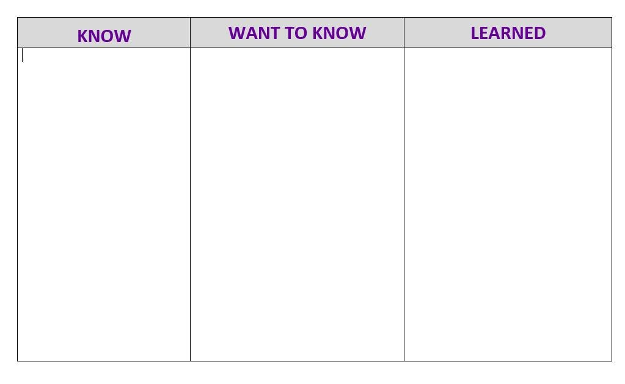

## Step 1

In column 1 you should review and record what you already **know**about the topic:

* What have you read or heard about this topic already?
* Can you summarise the main points or issues about the topic?
* How much detail can you go into? Can you identify key theories/models/data related to the topic?

## Step 2

Now you need to reflect on where you need to learn more. Analyse what you know and pinpoint the gaps in your knowledge so that you can address the areas where you need to focus your reading.

Ask yourself the following questions:

* Are you reading to understand and contextualise a topic/area?
* Are you reading to identify pertinent data/methods/research or evidence?
* Are you reading to deeply understand details?

In column 2 you can outline **what**you want to learn by writing a reading goal.

In having a clear understanding of why you are reading you can be sure that you are going to know when you have met your goal

## Step 3

Select your reading to meet the reading goal you identified.

# Establish the purpose of the text

Selecting reading can be challenging and you may be expected to read a variety of different types of academic text while studying. As well as book chapters you will also be expected to read academic published articles, research articles and reports as well [as a few more](https://medium.com/my-learning-essentials/glossary-of-information-types-e9a896ac3645) dependent upon your discipline.

These will differ in structure and complexity. Some of what you read will have a structure that you become familiar with over time, and this will lend a reassurance to your reading, however one valuable thing to consider before you begin reading is the **purpose of the text/author**.

* What information might the author be sharing and does it meet your reading goal?
* Why is the author using the format to share the information?
* How will the author achieve their purpose?
* Is the author providing the specific data or method that I need?

To do this you may have to do a little bit of research:

* **Research the author** and find out if they have written other papers in the same area/field.
* **Read the title, abstract or description**(this is specifically relevant to journal articles).An abstract is a very short summary of a research article outlining the aims, methods and main findings of the research. Reading the abstract allows you to identify if an article is relevant for you.

# Active reading

Engaging actively with your reading is crucial. Spending time organising how you will do this will help you stay focussed and productive. This means knowing exactly what you are going to do as you read and what tools you will use to help.

* What method of note-making will you use?
* How will you keep track of your notes and reading?

Look at the [MLE note-making resource](https://www.education.library.manchester.ac.uk/mle/note-making/) and at [this post explaining Cornell note-making technique](https://mlemanchester.medium.com/cornell-notes-8b2c5797a390) for how you could do this.

Being prepared and making a habit of reading using these strategies will ensure you become more efficient as a reader.

# Post reading activity

As a post reading activity return to your KWL to identify what you have learnt from your reading. Look back at the reading aims or any questions you posed in the Want-to-Know column and compare them with your notes.

* Did you accomplish what you set out to from reading the piece of text?
* Did you get everything you needed from it? If not, you can go back to the text.

# Summary

In this post we have talked you through an approach to pre-reading that will facilitate you in setting your purpose for reading. Using a pre-reading strategy such as KWL will allow you to prioritise and be more selective about the texts that you read. Furthermore, we encouraged you to read actively and make use of an organised approach to note-making. The Cornell approach is a good strategy to start with.